Appendix
CORTICES: Operative Management of Pediatric Thoracolumbar Spine Trauma

Appendix I: Inclusion and Exclusion Criteria Specifics
Examples and clarifications to better understand inclusion and exclusion criteria

Inclusion
- Pediatric patients aged 0 to 18.99 years at presentation.

- Patient who underwent spinal surgery for thoracolumbar (TL)* spinal trauma at CORTICES institutions between January 2002 and June 2025.

- Patients treated by Orthopaedics, Neurosurgery, or a combined Orthopaedic/Neurosurgery procedure

* TL Vertebral Levels = T1 – L5
PLEASE NOTE the FOLLOWING:
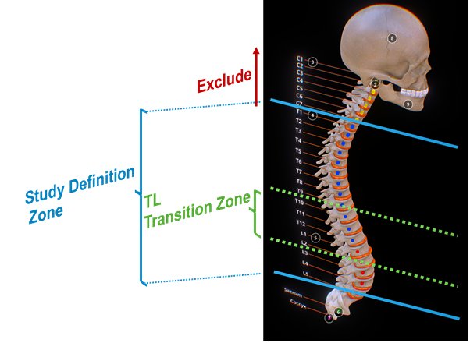
Traditional thoracolumbar (TL) region conceptualized as “transition zone” from T10 – L2
For this study, we define thoracolumbar region of the spine as any component of the Thoracic or Lumbar region T1 – L5.
Fractures extending cervicothoracic junction are to be excluded.
HOWEVER, fractures extending lumbosacral junction may be included given proximity to the TL transition zone and similar biomechanical considerations. Please confirm these boundary cases with PI on a case-by-case basis.
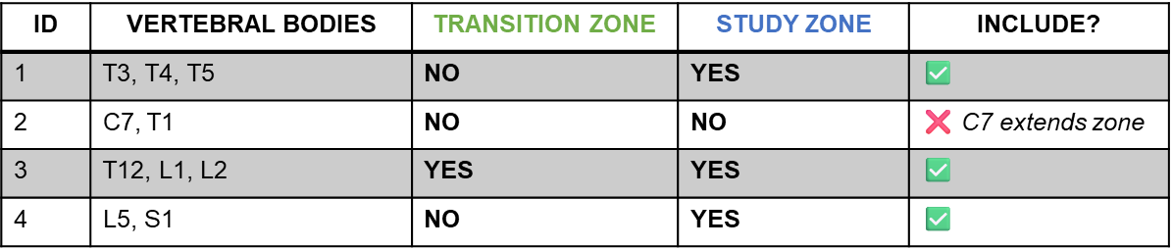
See examples below of boundary considerations:

Exclusion
- Underlying atraumatic spinal conditions that required prior surgery
Please review the scenarios below. Eligibility is not limited to prior instrumentation or fusion; any prior spinal procedure may impact inclusion. Confirm with the site PI as needed.

Scenario | Example | Exclusion Rationale
Prior fusion for AIS | 15-year-old with prior posterior spinal fusion (T4–L1) for Adolescent Idiopathic Scoliosis, later sustains TL fracture after MVC | Prior fusion alters native anatomy/biomechanics, limiting assessment of trauma-specific management
Prior instrumentation (pediatric) | 11-year-old with prior spinal instrumentation (e.g., growing rods) for non-traumatic deformity, later presents with TL fracture after fall | Existing hardware confounds injury characterization and surgical outcomes

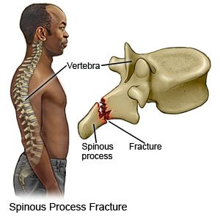
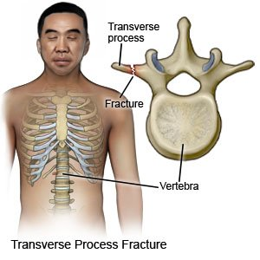
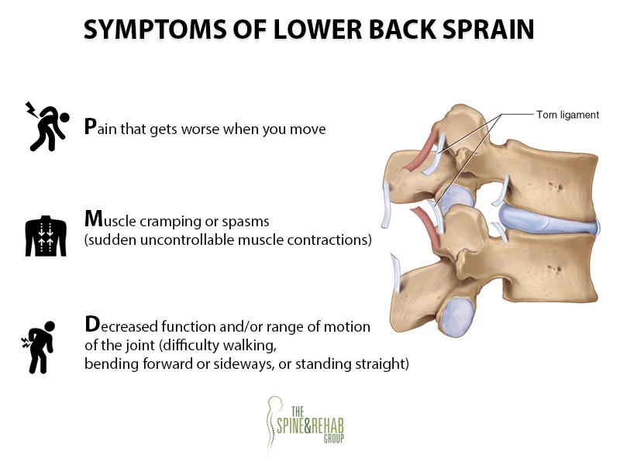
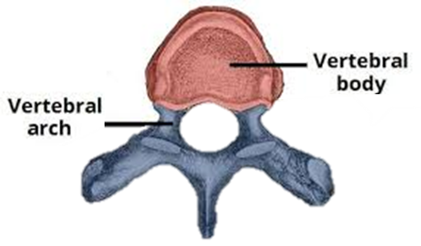
- Spinal injuries such as contusion or distortion or a) exclusive ligamentous injuries, isolated fractures of the b) spinous transverse or c) transverse processes, and d) the vertebral arch
A) Ligament Injury
B) Transverse Process Fx
C) Spinous Process Fx
D) Vertebral Arch vs Body

- Questionable fractures without clear radiologic evidence and/or incomplete radiological documentation

- Fractures were initially treated at an external hospital not part of CORTICES.

Scenario | Example | Exclusion Rationale
Initial tx at outside (non-CORTICES) site | 13-year-old with TL fracture initially managed with posterior instrumentation at an outside hospital; later presents to a CORTICES site for revision surgery due to hardware failure | Index injury and primary management occurred outside CORTICES, limiting consistency and completeness of initial treatment data

Appendix II: Additional Details on ICD + CPT Codes

Cohort
- Search year range: January 2002 to June 2025
- Cohort age range: 0—18 years old (>19 at time of surgery)
- Cohort Sex: All (Male and Female)
- Cohort clinical condition: Traumatic thoracolumbar spine fractures and injuries requiring surgery

CPT Codes:
22556; 22610; 22612; 22630; 22633; 22800; 22802; 22804; 22842; 22843; 22844; 63003; 63016; 63042; 63046; 63047; 63055; 63056; 63057; 63064
Please see below for full description of the CPT codes.

ICD Codes:

ICD-10
S22.0: Fracture of thoracic vertebra (S22.00 – S22.08)
S32.0: Fracture of lumbar vertebra (S32.00 – S32.05)
S24.1: Other and unspecified injuries of thoracic spinal cord (S24.10; S24.11; S24.15)*
S34.1: Other and unspecified injury of lumbar and sacral spinal cord (S34.10; S34.11; S34.12)*

ICD-9
805: Fracture of vertebral column without mention of spinal cord injury (805.2 – 805.5; 805.8*; 805.9*)
806: Fracture of vertebral column with spinal cord injury (806.2 – 806.5; 806.8*; 806.9*)
*NOTE: May capture cases related to spinal cord, but not spine itself; please use discretion*
Please see below for full description of the ICD 9/10 codes.

Recommended Approach:
Please identify eligible patients using the following “recommended” approach:
Primary Filter: Select encounters with any of the listed CPT codes that occur in conjunction with one or more relevant ICD-9/10 diagnosis codes for thoracic or lumbar spine fracture or spinal cord injury.

Additional Filter: If your institution has an informatics department capable of supporting advanced machine learning and/or AI approaches, consider identifying relevant patients by applying natural language processing (NLP) searches within operative notes for key trauma-related terms (e.g., “burst fracture,” “compression fracture,” “TLICS,” “thoracolumbar instrumentation,” “posterior fusion,” etc.).

Exclusion: If none of the trauma-related phrases are found in the operative note, please exclude the patient to avoid capturing non-traumatic spine surgical cases (e.g., scoliosis, infection, tumor).

PROCEDURAL CODES (Additional Breakdown)

Current Procedural Terminology (CPT) Code
Code | Category | Description (Source: Codify by AAPC)
22556 | Under Anterior or Anterolateral Approach Technique Arthrodesis Procedures on the Spine | The provider performs arthrodesis, also known as spinal fusion, in the upper back, to permanently join two vertebrae, the interlocking bones of the spine, to alleviate persistent pain caused by a herniated, or bulging, disk, or other spinal condition. He makes an incision in the side of the chest to access the spine and remove disk material.
22610 | Under Posterior, Posterolateral or Lateral Transverse Process Technique Arthrodesis Procedures on the Spine (Vertebral Column) | The provider performs arthrodesis, also known as spinal fusion, in the thoracic spine (upper back), to permanently join two vertebrae, the interlocking bones of the spine. The provider applies bone graft material to fuse the spine at the back of the vertebrae, at the back and side, or at the side and across. The procedure helps to alleviate persistent pain caused by various spinal conditions, including herniated intervertebral disks, stenosis, and spinal injuries.
22612 | Under Posterior, Posterolateral or Lateral Transverse Process Technique Arthrodesis Procedures on the Spine (Vertebral Column) | The provider performs arthrodesis, also known as spinal fusion, in the lumbar spine (lower back), to permanently join two vertebrae, the interlocking bones of the spine. The provider applies bone graft material to fuse the spine at the back of the vertebrae, at the back and side, or at the side and across. The procedure helps to alleviate persistent pain caused by various spinal conditions, including herniated intervertebral disks, stenosis, and spinal injuries.
22630 | Under Posterior, Posterolateral or Lateral Transverse Process Technique Arthrodesis Procedures on the Spine (Vertebral Column) | The provider performs an arthrodesis, also known as spinal fusion, in the lumbar spine, or lower back, to permanently join two vertebrae, the interlocking bones of the spine. He excises the lamina and disk material and applies bone graft between the disks to fuse them. The procedure helps to alleviate persistent pain caused by various spinal conditions, including herniated intervertebral disks, stenosis, or spinal injuries.
22633 | Under Posterior, Posterolateral or Lateral Transverse Process Technique Arthrodesis Procedures on the Spine (Vertebral Column) | In this procedure the provider joins two adjoining lumbar vertebral bodies permanently, accessing the operative site with a combination of approaches for a better outcome. The provider performs this procedure to prevent any further damage or pain in the joint.
22800 | Under Arthrodesis Procedures for Spine Deformity (e.g., Scoliosis, Kyphosis) | The provider performs arthrodesis, also known as spinal fusion, to secure different vertebrae to one another. This procedure helps to treat and alleviate persistent pain caused by various spinal deformities, such as scoliosis or kyphosis, abnormal curvatures of the spine. He performs the procedure on up to six vertebral segments. He may apply a body cast.
22802 | Under Arthrodesis Procedures for Spine Deformity (e.g., Scoliosis, Kyphosis) | The provider performs arthrodesis, also known as spinal fusion, to secure different vertebrae to one another. This procedure helps to treat and alleviate persistent pain caused by various spinal deformities, such as scoliosis or kyphosis, abnormal curvatures of the spine. He performs the procedure on seven to twelve vertebral segments. He may apply a body cast.
22804 | Under Arthrodesis Procedures for Spine Deformity (e.g., Scoliosis, Kyphosis) | The provider performs arthrodesis, also known as spinal fusion, to secure different vertebrae to one another. This procedure helps to treat and alleviate persistent pain caused by various spinal deformities, such as scoliosis or kyphosis, abnormal curvatures of the spine. He performs the procedure on 13 or more vertebral segments. He may apply a body cast.
22842 | Under Spinal Instrumentation Procedures on the Spine (Vertebral Column) | The provider places spinal instrumentation at the back of the spine across three to six vertebral segments to correct a spinal deformity during the course of a spinal surgery, such as a spinal fusion, or arthrodesis.
22843 | Under Spinal Instrumentation Procedures on the Spine (Vertebral Column) | The provider places spinal instrumentation at the back of the spine across seven to twelve vertebral segments to correct a spinal deformity during the course of a spinal surgery, such as a spinal fusion, or arthrodesis.
22844 | Under Spinal Instrumentation Procedures on the Spine (Vertebral Column) | The provider places spinal instrumentation at the back of the spine across 13 or more vertebral segments to correct a spinal deformity during the course of a spinal surgery, such as a spinal fusion, or arthrodesis.
63003 | Under Posterior Extradural Laminotomy or Laminectomy for Exploration/ Decompression of Neural Elements or Excision of Herniated Intervertebral Disks Procedures | This procedure is the laminectomy of one or two thoracic vertebral segments with exploration and/or decompression of the spinal cord and/or cauda equina. This procedure does not contain a facetectomy, foraminotomy, or discectomy.
63016 | Under Posterior Extradural Laminotomy or Laminectomy for Exploration/ Decompression of Neural Elements or Excision of Herniated Intervertebral Disks Procedures | This procedure is laminectomy of more than two thoracic vertebral segments with exploration and/or decompression of the spinal cord and/or cauda equina. This procedure does not contain a facetectomy, foraminotomy, or discectomy.
63042 | Under Posterior Extradural Laminotomy or Laminectomy for Exploration/ Decompression of Neural Elements or Excision of Herniated Intervertebral Disks Procedures | This procedure is laminotomy of one lumbar interspace with decompression of the nerve root(s), and includes a partial facetectomy, foraminotomy, and/or the excision of a herniated intervertebral disc. This procedure is a reexploration.
63046 | Under Posterior Extradural Laminotomy or Laminectomy for Exploration/ Decompression of Neural Elements or Excision of Herniated Intervertebral Disks Procedures | This procedure is a single thoracic vertebral laminectomy, facetectomy, and foraminotomy.
63047 | Under Posterior Extradural Laminotomy or Laminectomy for Exploration/ Decompression of Neural Elements or Excision of Herniated Intervertebral Disks Procedures | The provider performs a laminectomy (excision of the thin bony plate at the back of a vertebra), facetectomy (excision of an area of a vertebra characterized by its smooth surface), and foraminotomy (incision into the vertebral opening through which nerve bundles exit out to the body) at a single lumbar vertebral segment to correct spinal stenosis (narrowing) and decompress the spinal cord or nerve roots.
63055 | Under Transpedicular or Costovertebral Approach for Posterolateral Extradural Exploration/Decompression Procedures on the Spine and Spinal Cord | The provider uses a transpedicular approach to repair a bulging thoracic disc without manipulating the spinal cord. The approach is through the side of the pedicle of one thoracic vertebra. This service is done to relieve pressure on the spinal cord, equina, or nerve roots.
63056 | Under Transpedicular or Costovertebral Approach for Posterolateral Extradural Exploration/Decompression Procedures on the Spine and Spinal Cord | The provider uses a transpedicular approach to repair a bulging lumbar disc without manipulating the spinal cord. The approach is through the side of the pedicle of one lumbar vertebra, known as a transpedicular approach. A far lateral herniated intervertebral disc may require a different approach such as a transfacet or lateral extraforaminal approach. This service is done to relieve pressure on the spinal cord, equina, or nerve roots.
63057 | Under Transpedicular or Costovertebral Approach for Posterolateral Extradural Exploration/Decompression Procedures on the Spine and Spinal Cord | In this add on procedure, the provider repairs another bulging thoracic or lumbar disc without manipulating the spinal cord. Using the transpedicular approach, the provider accesses the affected disc through the side of the pedicle of another thoracic or lumbar vertebra.
63064 | Under Transpedicular or Costovertebral Approach for Posterolateral Extradural Exploration/Decompression Procedures on the Spine and Spinal Cord | To relieve symptoms caused by spinal cord or nerve root pressure, the provider performs a decompression service on a single thoracic segment, such as removing a disc from the spine. He uses a costovertebral approach, which refers to where the ribs and spine meet.

DIAGNOSTIC CODES (Additional Breakdown)

ICD-10-CM (Clinical Modification) Codes
- S22.0 Fracture of thoracic vertebra
  - S22.00 Fracture of unspecified thoracic vertebra
    - S22.000 Wedge compression fracture of unspecified thoracic vertebra
    - S22.001 Stable burst fracture of unspecified thoracic vertebra
    - S22.002 Unstable burst fracture of unspecified thoracic vertebra
    - S22.008 Other fracture of unspecified thoracic vertebra
    - S22.009 Unspecified fracture of unspecified thoracic vertebra

  - S22.01 Fracture of first thoracic vertebra
    - S22.010 Wedge compression fracture of first thoracic vertebra
    - S22.011 Stable burst fracture of first thoracic vertebra
    - S22.012 Unstable burst fracture of first thoracic vertebra
    - S22.018 Other fracture of first thoracic vertebra
    - S22.019 Unspecified fracture of first thoracic vertebra

  - S22.02 Fracture of second thoracic vertebra
    - S22.020 Wedge compression fracture of second thoracic vertebra
    - S22.021 Stable burst fracture of second thoracic vertebra
    - S22.022 Unstable burst fracture of second thoracic vertebra
    - S22.028 Other fracture of second thoracic vertebra
    - S22.029 Unspecified fracture of second thoracic vertebra

  - S22.03 Fracture of third thoracic vertebra
    - S22.030 Wedge compression fracture of third thoracic vertebra
    - S22.031 Stable burst fracture of third thoracic vertebra
    - S22.032 Unstable burst fracture of third thoracic vertebra
    - S22.038 Other fracture of third thoracic vertebra
    - S22.039 Unspecified fracture of third thoracic vertebra

  - S22.04 Fracture of fourth thoracic vertebra
    - S22.040 Wedge compression fracture of fourth thoracic vertebra
    - S22.041 Stable burst fracture of fourth thoracic vertebra
    - S22.042 Unstable burst fracture of fourth thoracic vertebra
    - S22.048 Other fracture of fourth thoracic vertebra
    - S22.049 Unspecified fracture of fourth thoracic vertebra
  - S22.05 Fracture of T5-T6 vertebra
    - S22.050 Wedge compression fracture of T5-T6 vertebra
    - S22.051 Stable burst fracture of T5-T6 vertebra
    - S22.052 Unstable burst fracture of T5-T6 vertebra
    - S22.058 Other fracture of T5-T6 vertebra
    - S22.059 Unspecified fracture of T5-T6 vertebra

  - S22.06 Fracture of T7-T8 vertebra
    - S22.060 Wedge compression fracture of T7-T8 vertebra
    - S22.061 Stable burst fracture of T7-T8 vertebra
    - S22.062 Unstable burst fracture of T7-T8 vertebra
    - S22.068 Other fracture of T7-T8 thoracic vertebra
    - S22.069 Unspecified fracture of T7-T8 vertebra

  - S22.07 Fracture of T9-T10 vertebra
    - S22.070 Wedge compression fracture of T9-T10 vertebra
    - S22.071 Stable burst fracture of T9-T10 vertebra
    - S22.072 Unstable burst fracture of T9-T10 vertebra
    - S22.078 Other fracture of T9-T10 vertebra
    - S22.079 Unspecified fracture of T9-T10 vertebra

  - S22.08 Fracture of T11-T12 vertebra
    - S22.080 Wedge compression fracture of T11-T12 vertebra
    - S22.081 Stable burst fracture of T11-T12 vertebra
    - S22.082 Unstable burst fracture of T11-T12 vertebra
    - S22.088 Other fracture of T11-T12 vertebra
    - S22.089 Unspecified fracture of T11-T12 vertebra

- S32.0 Fracture of lumbar vertebra
  - S32.00 Fracture of unspecified lumbar vertebra
    - S32.000 Wedge compression fracture of unspecified lumbar vertebra
    - S32.001 Stable burst fracture of unspecified lumbar vertebra
    - S32.002 Unstable burst fracture of unspecified lumbar vertebra
    - S32.008 Other fracture of unspecified lumbar vertebra
    - S32.009 Unspecified fracture of unspecified lumbar vertebra

  - S32.01 Fracture of first lumbar vertebra
    - S32.010 Wedge compression fracture of first lumbar vertebra
    - S32.011 Stable burst fracture of first lumbar vertebra
    - S32.012 Unstable burst fracture of first lumbar vertebra
    - S32.018 Other fracture of first lumbar vertebra
    - S32.019 Unspecified fracture of first lumbar vertebra

  - S32.02 Fracture of second lumbar vertebra
    - S32.020 Wedge compression fracture of second lumbar vertebra
    - S32.021 Stable burst fracture of second lumbar vertebra
    - S32.022 Unstable burst fracture of second lumbar vertebra
    - S32.028 Other fracture of second lumbar vertebra
    - S32.029 Unspecified fracture of second lumbar vertebra

  - S32.03 Fracture of third lumbar vertebra
    - S32.030 Wedge compression fracture of third lumbar vertebra
    - S32.031 Stable burst fracture of third lumbar vertebra
    - S32.032 Unstable burst fracture of third lumbar vertebra
    - S32.038 Other fracture of third lumbar vertebra
    - S32.039 Unspecified fracture of third lumbar vertebra

  - S32.04 Fracture of fourth lumbar vertebra
    - S32.040 Wedge compression fracture of fourth lumbar vertebra
    - S32.041 Stable burst fracture of fourth lumbar vertebra
    - S32.042 Unstable burst fracture of fourth lumbar vertebra
    - S32.048 Other fracture of fourth lumbar vertebra
    - S32.049 Unspecified fracture of fourth lumbar vertebra

  - S32.05 Fracture of fifth lumbar vertebra
    - S32.050 Wedge compression fracture of fifth lumbar vertebra
    - S32.051 Stable burst fracture of fifth lumbar vertebra
    - S32.052 Unstable burst fracture of fifth lumbar vertebra
    - S32.058 Other fracture of fifth lumbar vertebra
    - S32.059 Unspecified fracture of fifth lumbar vertebra

- S24.1 Other and unspecified injuries of thoracic spinal cord*
  - S24.10 Unspecified injury of thoracic spinal cord*
    - S24.101 Unspecified injury at T1 level of thoracic spinal cord
    - S24.102 Unspecified injury at T2-T6 level of thoracic spinal cord
    - S24.103 Unspecified injury at T7-T10 level of thoracic spinal cord
    - S24.104 Unspecified injury at T11-T12 level of thoracic spinal cord
    - S24.109 Unspecified injury at unspecified level of thoracic spinal cord

  - S24.11 Complete lesion of thoracic spinal cord*
    - S24.111 Complete lesion at T1 level of thoracic spinal cord
    - S24.112 Complete lesion at T2-T6 level of thoracic spinal cord
    - S24.113 Complete lesion at T7-T10 level of thoracic spinal cord
    - S24.114 Complete lesion at T11-T12 level of thoracic spinal cord
    - S24.119 Complete lesion at unspecified level of thoracic spinal cord

  - S24.15 Other incomplete lesions of thoracic spinal cord*
    - S24.151 Other incomplete lesion at T1 level of thoracic spinal cord
    - S24.152 Other incomplete lesion at T2-T6 level of thoracic spinal cord
    - S24.153 Other incomplete lesion at T7-T10 level of thoracic spinal cord
    - S24.154 Other incomplete lesion at T11-T12 level of thoracic spinal cord
    - S24.159 Other incomplete lesion at unspecified level of thoracic spinal cord

- S34.1 Other and unspecified injury of lumbar and sacral spinal cord*
  - S34.10 Unspecified injury to lumbar spinal cord*
    - S34.101 Unspecified injury to L1 level of lumbar spinal cord
    - S34.102 Unspecified injury to L2 level of lumbar spinal cord
    - S34.103 Unspecified injury to L3 level of lumbar spinal cord
    - S34.104 Unspecified injury to L4 level of lumbar spinal cord
    - S34.105 Unspecified injury to L5 level of lumbar spinal cord
    - S34.109 Unspecified injury to unspecified level of lumbar spinal cord

  - S34.11 Complete lesion of lumbar spinal cord*
    - S34.111 Complete lesion of L1 level of lumbar spinal cord
    - S34.112 Complete lesion of L2 level of lumbar spinal cord
    - S34.113 Complete lesion of L3 level of lumbar spinal cord
    - S34.114 Complete lesion of L4 level of lumbar spinal cord
    - S34.115 Complete lesion of L5 level of lumbar spinal cord
    - S34.119 Complete lesion of unspecified level of lumbar spinal cord

  - S34.12 Incomplete lesion of lumbar spinal cord*
    - S34.121 Incomplete lesion of L1 level of lumbar spinal cord
    - S34.122 Incomplete lesion of L2 level of lumbar spinal cord
    - S34.123 Incomplete lesion of L3 level of lumbar spinal cord
    - S34.124 Incomplete lesion of L4 level of lumbar spinal cord
    - S34.125 Incomplete lesion of L5 level of lumbar spinal cord
    - S34.129 Incomplete lesion of unspecified level of lumbar spinal cord

*NOTE: May capture cases related to spinal cord, but not spine itself; please use discretion*

ICD-9-CM (Clinical Modification) Codes

Thoracic Fractures
- 805.2: Closed fracture of dorsal [thoracic] vertebra without mention of spinal cord injury
- 805.3: Open fracture of a dorsal [thoracic] vertebra without mention of spinal cord injury
- 806.2: Closed fracture of a dorsal (thoracic) vertebra with a spinal cord injury
  - 806.20: Closed fracture of T1-T6 level with unspecified spinal cord injury
  - 806.21: Closed fracture of T1-T6 level with complete lesion of cord
  - 806.22: Closed fracture of T1-T6 level with anterior cord syndrome
  - 806.23: Closed fracture of T1-T6 level with central cord syndrome
  - 806.24: Closed fracture of T1-T6 level with other specified spinal cord injury
  - 806.25: Closed fracture of T7-T12 level with unspecified spinal cord injury
  - 806.26: Closed fracture of T7-T12 level with complete lesion of cord
  - 806.27: Closed fracture of T7-T12 level with anterior cord syndrome
  - 806.28: Closed fracture of T7-T12 level with central cord syndrome
  - 806.29: Closed fracture of T7-T12 level with other specified spinal cord injury
- 806.3: Open fracture of a dorsal (thoracic) vertebra with a spinal cord injury
  - 806.30: Open fracture of T1-T6 level with unspecified spinal cord injury
  - 806.31: Open fracture of T1-T6 level with complete lesion of cord
  - 806.32: Open fracture of T1-T6 level with anterior cord syndrome
  - 806.33: Open fracture of T1-T6 level with central cord syndrome
  - 806.34: Open fracture of T1-T6 level with other specified spinal cord injury
  - 806.35: Open fracture of T7-T12 level with unspecified spinal cord injury
  - 806.36: Open fracture of T7-T12 level with complete lesion of cord
  - 806.37: Open fracture of T7-T12 level with anterior cord syndrome
  - 806.38: Open fracture of T7-T12 level with central cord syndrome
  - 806.39: Open fracture of T7-T12 level with other specified spinal cord injury
Lumbar Fractures
- 805.4: Closed fracture of a lumbar vertebra without mention of spinal cord injury
- 805.5: Open fracture of a lumbar vertebra without mention of spinal cord injury
- 806.4: Closed fracture of the lumbar spine with spinal cord injury
- 806.5: Open fracture of lumbar spine with spinal cord injury

Unspecified Vertebrae Fractures
- 805.8: Closed fracture of unspecified vertebral column without mention of spinal cord injury*
- 805.9: Open fracture of unspecified vertebral column without mention of spinal cord injury*
- 806.8: Closed fracture of unspecified vertebral column with spinal cord injury*
- 806.9: Open fracture of unspecified vertebral column with spinal cord injury*

*NOTE: May capture cases related to spinal cord, but not spine itself; please use discretion*

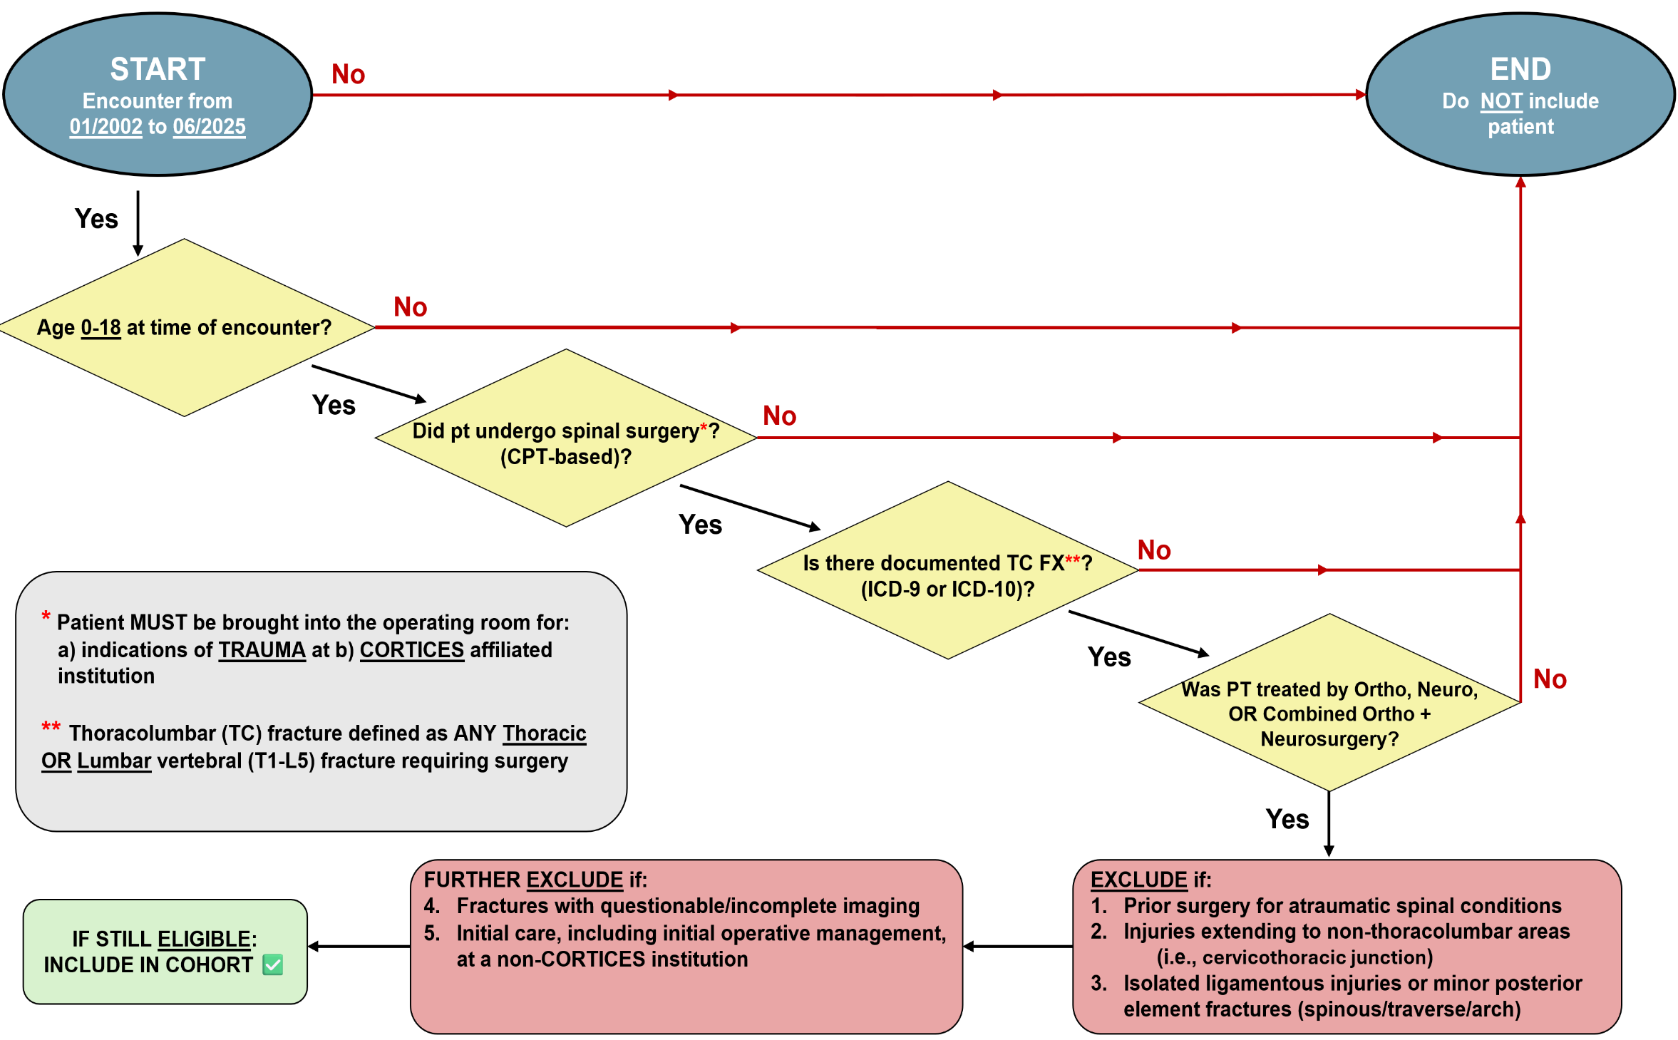
Appendix III: Patient Screening Flowchart

