Standard Operating Procedures for CORTICES Registry – Femoral Neck Fractures Data Entry

When entering your patient data, you will be asked to enter a new or existing Record ID. Please use your 2-digit Unique Site Number (shown below) for your site’s data.
Site # | Site | Site # | Site
20 | Boston Children’s | 30 | Le Bonheur Children’s
22 | Children’s Atlanta | 31 | Lurie Children’s
23 | Children’s Colorado | 32 | Nationwide Children’s
24 | Children’s Dallas | 33 | Rady Children’s
25 | Children’s LA USC | 34 | Seattle Children’s
26 | Children’s Philadelphia | 35 | St. Louis Children’s
27 | Cincinnati Children’s | 36 | Texas Children’s
28 | CS Mott Children’s (Michigan) | 37 | Vanderbilt Children’s
29 | Gillette Children’s | 38 | UCSF

To generate your REDCap Record IDs, please use the following format (below), where ‘S’ is the 2-digit site code and ‘P’ is the 3-digit record ID. The IDs should be sequentially recorded.
S S – P P P
2-digit Unique Site Number
3-digit Sequential Patient ID Number
For example, BCH’s first patient would have a REDCap ID of “20-001”. BCH’s twentieth patient would have a REDCap ID of ’20-020’. It is crucial that sites use the correct site ID to avoid duplicate REDCap IDs.

*Note: If you were a site involved with testing this REDCap and inputted training data (Lurie Children’s and other Beta sites), please review all fields for your test patients as the REDCap could have changed as result of the beta testing. You may keep the same Record ID for the test patient, but the data must be re-validated.

Patient Search

Patients diagnosed with femoral neck fractures between 1/10/2010 and 6/30/2024 who were between 2 and 16 years old at time of presentation. Listed below are ICD-9 and ICD-10 codes that can be used to search for all patients with a diaphyseal femur fracture.

ICD-10 Codes Search Query
S72.00 | Fracture of unspecified part of neck of femur
S72.01 | Unspecified intracapsular fracture of femur
S72.03 | Midcervical fracture of femur
S72.04 | Fracture of base of neck of femur
S72.05 | Unspecified fracture of head of femur
S72.09 | Other fracture of head and neck of femur
S72.10 | Unspecified trochanteric fracture of femur
S72.14 | Intertrochanteric fracture of femur
S72.2 | Subtrochanteric fracture of the femur
S72.8 | Other fracture of the femur
S72.9 | Unspecified fractures of the femur

ICD-9 Codes Search Query
733.14 | Pathologic fracture of neck of femur
733.15 | Pathologic fracture of other specified part of femur
733.96 | Stress fracture of femoral neck
820.02 | Closed fracture of midcervical section of neck of femur
820.03 | Closed fracture of base of neck of femur
820.09 | Other closed transcervical fracture of neck of femur
820.10 | Open fracture of intracapsular section of neck of femur, unspecified
820.12 | Open fracture of midcervical section of neck of femur
820.13 | Open fracture of base of neck of femur
820.19 | Other open transcervical fracture of neck of femur
820.20 | Closed fracture of trochanteric section of neck of femur
820.21 | Closed fracture of intertrochanteric section of neck of femur
8202.2 | Closed fracture of subtrochanteric section of neck of femur
8203.0 | Open fracture of trochanteric section of neck of femur, unspecified
8203.1 | Open fracture of intertrochanteric section of neck of femur
8203.2 | Open fracture of subtrochanteric section of neck of femur
820.8 | Closed fracture of unspecified part of neck of femur

Study-Specific Definitions

A femoral neck fracture in this study is defined as a fracture sustained in a region boarded proximally through the physis (Delbet I) and distally as proximal to the lesser trochanter (Delbet IV). While traumatic epiphyseal separation, or Type 1 Delbet fractures are hard to distinguish from a Slipped Capital Femoral Epiphysis (SCFE) (ICD-9 732.2 or ICD-10 code M93.0), they will initially be included in analysis, but cases will be scrutinized by the on-site PI for appropriate determination. Additionally, Salter-Harris II fractures with a metaphyseal fragment are included.

Surgical Intervention Shorthand:
Fracture location:
Delbet classification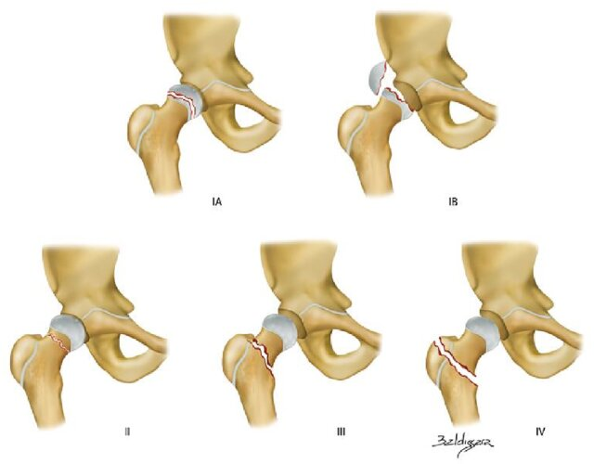

INCLUDE

Text synonyms for searches: Neck of femur, intertrochanteric fracture, basicervical are some names. Surgeries are cannulated screws, DHS, Open reduction internal fixation
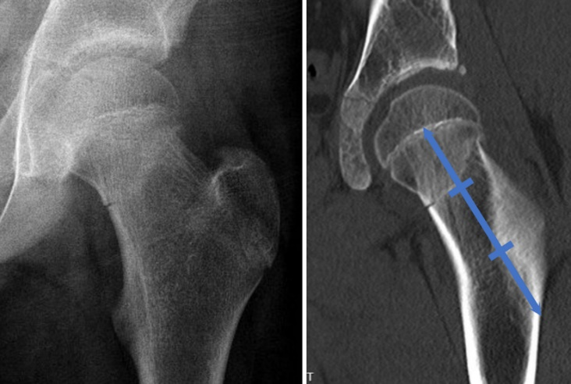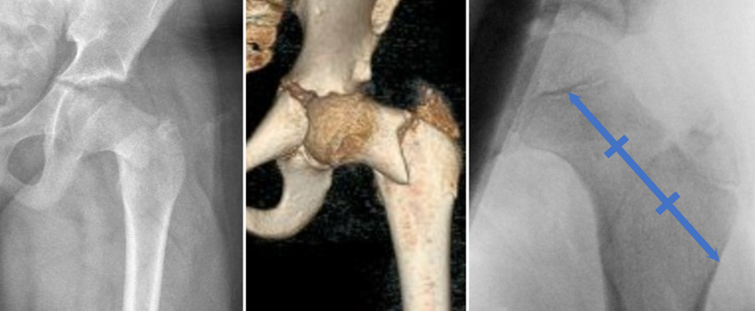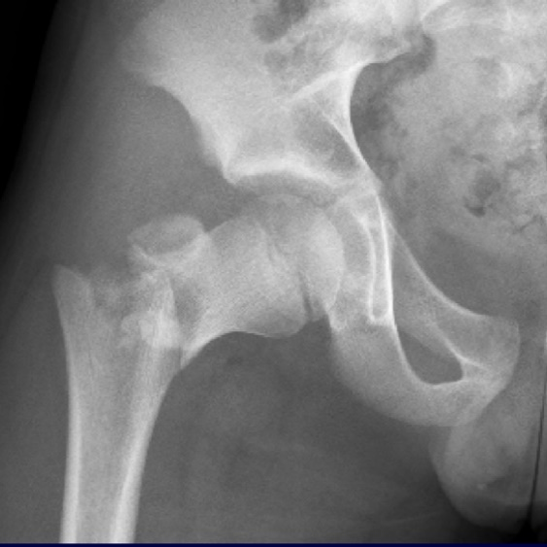

Form Completion Technique
All data is to be entered directly into REDCap from the medical records. There are two REDCap forms: General and Imaging. The general form is to be completed by the participating centers. Imaging for each patient will be exported and uploaded to BCH’s REDCap, and the imaging measurements will be done by 1-2 surgeon later.

When entering data, please follow the rules below:

- Mark REDCap page status for each form as appropriate:
  - Incomplete (RED): Data not fully entered yet.
  - Complete (GREEN): All data points are fully entered including missing codes.

- Use correct missing codes (no fields/questions should be blank)
  - Next to the question you will see a M in a circle: Please choose the proper missing code
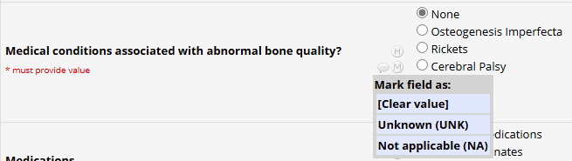

Eligibility - REDCap

In REDCap include all those patients that meet the inclusion and then determine if they meet or not exclusion criteria for eligibility in the study:

Inclusion:
- Patients with femoral neck fracture defined as Delbet 1, 2, 3, and 4 fractures distal to the physis and proximal to the lesser trochanter, or Salter Harris 2 fractures.
- Presented between 1/10/2010 and 5/30/2025
- Age 2 to ≤ 16 years at date of injury presentation
- Presented at, transferred to, or followed up at a CORTICES-participating institution. Patients who were not initially treated at a participating center will be included if injury films are available.
- Patient should be ambulatory prior to injury
- Patients who are non-ambulatory or with poor bone quality (CP, arthrogryposis, SMA, Spina bifida, etc) will be included but noted on inclusion sheet as “non-ambulatory at baseline” and/or “abnormal bone quality”
- Minimum imaging requirements: Initial injury films and at least one follow-up image. For Patients who underwent surgery, intra-op or early post-op is also required.

Exclusion:
- Atraumatic physeal injuries: Slipped Capital femoral epiphysis (ICD-9 732.2 or ICD-10 code M93.0)

Data – REDCap

General form
Patient Characteristics
Date of birth
  - Enter the patient’s date of birth in the MM/DD/YYYY format
Patient Sex
  - Indicate whether patient is Male or Female
Height
- Enter patient’s height at presentation in centimeters. If unavailable, the closet reading to the injury date (within 6 months) is acceptable.
Weight
- Enter patient’s weight in kilograms. If unavailable, the closet reading to the injury date (within 6 months) is acceptable.
BMI
- Calculated field
Heath Equity
- Enter COI: https://www.diversitydatakids.org/child-opportunity-index
- Enter ADI: https://www.neighborhoodatlas.medicine.wisc.edu/
Ambulatory Status
- Patient was ambulatory prior to injury
- Non ambulatory prior to injury
History of long bone fractures
- Indicate whether patient has a history of diaphyseal long bone fractures (e.g., humeral shaft, both bone forearm). If answered yes, enter the number of previous long bone fractures.
Medical conditions associated with abnormal bone quality
  - Indicate if patient has underlying conditions that increase the risk of fractures. Pathologies of interest are OI, rickets, CP, SMA, spina bifida, and autism, but there is a box for “other” pathologies as well for example pathologic fractures due to malignancy and unicameral bone cysts (UBC).
Medications
- Indicate if patient is being treated with medications that affect bone quality, including epilepsy medications, bisphosphonates, steroids, or others. See Appendix A for a complete list of medications.
Injury Characteristics
Date of injury
- Enter date of injury in the MM/DD/YYYY format
Time of injury
- Enter time of injury in 24H format
Mechanism of injury
- Indicate whether the injury was caused by a low-injury mechanism (simple falls <4 feet, sports injuries) or high-energy mechanism (motor vehicle accident, gunshot, falls >4 feet)
Polytrauma status
- Indicate if the patient was considered a polytrauma at arrival (ISS>15, PICU admission, multiple fractures, need for intubation in the ED, etc.)
  - Yes = i.e ISS>15, PICU admission, multiple fractures, need for intubation in the ED, etc
  - No = isolated fracture
Comment: sites of other fractures
Open fracture?
- Was the femoral neck fracture open?
Prodromal symptoms prior to fracture?
- Indicate whether the patient had symptoms (pain, limping) prior to the fracture. This would likely indicate a pathologic fracture.

Treatment Characteristics
Date of admission
  - Enter the date of admission in MM/DD/YYYY format
Time of admission
- Enter the time of admission in 24H format

Surgery performed at home institution?
- Yes/No
Date of surgery
  - Enter the date of surgery in MM/DD/YYYY format
OR in-room time
- Enter the time the patient was rolled into the OR room in 24H format
OR out of room time
- Enter the time the patient was rolled out of the OR room in 24H format
Surgical table used
- Select the surgical table used: Flat Jackson, Hana, Traditional fracture table, regular OR table, or other

Skeletal traction
- Was skeletal traction (bi-cortical pin, not external) used pre-operatively (Y/N)
- Was skeletal traction (bi-cortical pin, not external) used intra-operatively (Y/N)

If traction was used, what was the duration: HH:MM:SS

Fracture Reduction Technique
Closed / Percutaneous assisted / Open
Surgical approach(es)
- Surgical approach(es) (select all approaches used) There could be more than one approach, e.g., fracture reduction was achieved through an anterior approach and instrumentation through a lateral approach.
  - 1, Anterior (Smith-Peterson)
  - 2, Anterolateral (Watson-Jones)
  - 3, Direct lateral
  - 4, Surgical Dislocation approach

Instrumentation technique
1, Percutaneous instrumentation
2, Instrumentation through the surgical approach used for reduction
3, Separate approach for instrumentation
Final hardware construct
- Select the final hardware construct. Do not include temporary wires used to provisionally hold the fracture while instrumenting but may select more than one below if a "mixed-hardware" construct used.
  - 1, K-wires
  - 2, Solid screws
  - 3, Cannulated screws
  - 4, Locking plate
  - 5, Fixed angle device (e.g., Angled blade plate, DHS, FNS)
  - 6, Intramedullary nail
Was femoral head perfusion monitored intraoperatively
- Indicate whether a perfusion monitoring device (Arterial line monitor, Camino, ICP monitor) was used to assess the femoral head perfusion intraoperatively. If answered yes, include the findings from the operative note.
- Results of perfusion, examples: wave form present? systolic pressure, diastolic pressure and pulse pressure.

Was capsulotomy done
- The operative note will explicitly indicate if this is done. If answered yes, this could be percutaneous (using a Cobb elevator or other surgical instruments) or through a separate open surgical approach (less common).

Post-operative course
Post-operative immobilization
- Indicate whether any form of immobilization was used post-operatively, including a cast, brace, or traction (skeletal or skin) or other.
Date full weight-bearing was allow
- Enter the post-op clinic visit date on which the patient was allowed to fully bear weight on the injured limb. This is often in the form of gradual increased weight bearing with crutches.
Was the patient referred to bone health?
- Indicate whether the patient was referred to a bone health specialist, e.g. bone health clinic, endocrinologist, etc. If answered yes, enter the recommendations in the comments box.
Vitamin D level
- Enter the Vitamin D level if checked. A measurement within 1 month of the fracture is acceptable.

Adverse Outcome – Can enter up to 3 different adverse outcomes
Did the patient have an Adverse Outcome? Y/N

Date of the adverse outcome

Time period of adverse outcome since surgery date
(≤ 3 mo, ≤6 mo, ≤12 mo, ≤18 mo, ≤24 mo)
Grade of Adverse Outcomes
- Grade 1 – complication requires no treatment, no deviation from post-op course
- Grade 2 – deviation from normal post-op course requiring outpatient treatment (pharm/close monitoring)
  - Superficial infection: resolved with observation or antibiotics
- Grade 3 – treatable, but requires surgical, endoscopic, or interventional radiology procedures or unplanned hospital admission
  - Deep infection: required a return to the operating room and/or admission
  - Hardware related complications: This includes hardware prominence, broken hardware, loose hardware, or hardware penetrating the joint. Does NOT include planned hardware removal for surgeon/family preference.
- Grade 4 – life- or limb-threatening and/or requires ICU admission
  - 4a – potential for long-term disability, but treatable (may require organ/joint resection/replacement).
    - Nonunion (lack of healing at >6 months and/or loss of mechanical integrity with respect to implanted hardware)
    - Malunion (vertical or femoral neck shortening of >15 mm)
  - 4b – not treatable or with long-term disability, requiring require organ/joint resection/replacement)
    - AVN: as diagnosed on MRI or evidence of collapse on x-rays (according to the modified Ficat system with type 2b and greater defined as clinical failure)
    - 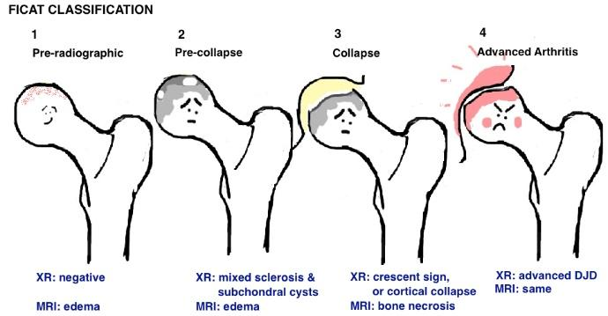
    - Subsequent major reconstructive surgery required (conversion to THA or proximal femur osteotomy)

- Grade 5 – Death

Specifics of adverse outcome:
1, Superficial infection
2, Deep infection (requiring return to the OR)
3, AVN
4, Nonunion
5, Malunion
6, Hardware related complications
7, Other

Treatment of adverse outcome:
  - I&D: irrigation and debridement for an infection
  - Hardware removal: e.g., screws penetrating the joint
  - Hardware revision: e.g., screws removed and replaced
  - Revascularization procedure: in case of early AVN, the surgeon may elect to perform a surgical procedure with the intention of revascularizing the femoral head.
  - Femoral osteotomy
  - Pelvic osteotomy
  - Arthroplasty
  - Other: fill in the comment box

Was hardware removed
- Indicate whether hardware was removed for any reason. If answered yes, select the reason(s), including elective, symptomatic hardware, infection, joint penetration, or other (comment).
Functional Outcome at Final Follow-up
- Indicate whether the outcome was ”Back to pre-operative baseline” or “other”. While it is difficult to dichotomize the outcome, this is more about how the hip is functioning through the follow-up period. A patient who experienced a minor infection, and later had a planned hardware removal, but is back to walking and running without pain and minimal limp (Trendelenburg) is back to functional baseline. A patient who has AVN and needs a THA is not. Please include details of the unsatisfactory final functional outcome in the text box.

Imaging upload form
This form is used to upload imaging files associated with the documented measurements. OPTIONAL but encouraged to upload images if file size is manageable as these images will serve as quality control. Make sure the images are de-identified.

Injury Imaging
- Injury x-rays are required to measure/report imaging characteristics; uploading imaging is optional.
- Option to upload additional x-rays

Intra-operative imaging
- Fluoroscopy images

First post-operative imaging
- First post-operative X-rays: during admission, or in the first 4 weeks during clinic visits
- Bone scan: DICOM files not needed, only an image of the report

Adverse event imaging
- Adverse event x-rays

Final imaging
- Final x-rays, option for additional x-rays

Imaging Findings

Initials of the person filling out the form – PI from representative site

Date of Image being evaluated MM:DD:YYYY

Fracture location
- Select the fracture location. A line is drawn from the center of the physis parallel to the femoral neck down to the lateral femoral cortex, and divided in thirds.
  - Type I: proximal third, subcapital, aka Delbet type 1 and 2
  - Type II: Middle third, transcervical, aka Delbet

  - type 3

  - Type III: distal third, basicervical, aka Delbet type 4
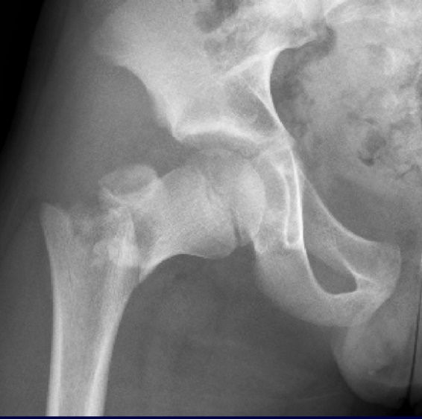

Fracture type description
- Select the fracture type, including incomplete (fracture line in only one cortex), complete (fracture extends to both cortices), Stress (chronic symptoms, often seen on MRI only), impacted (more common in individuals with fragile bone, no visible fracture line but the femoral neck height is diminished, hence “impacted”.

Pauwels type (fracture angulation)
- The angle between a line drawn parallel to the fracture line and a horizontal line.
  - Type I: <30 degrees
  - Type II: 30-50 degrees
  - Type III: >50 degrees
- 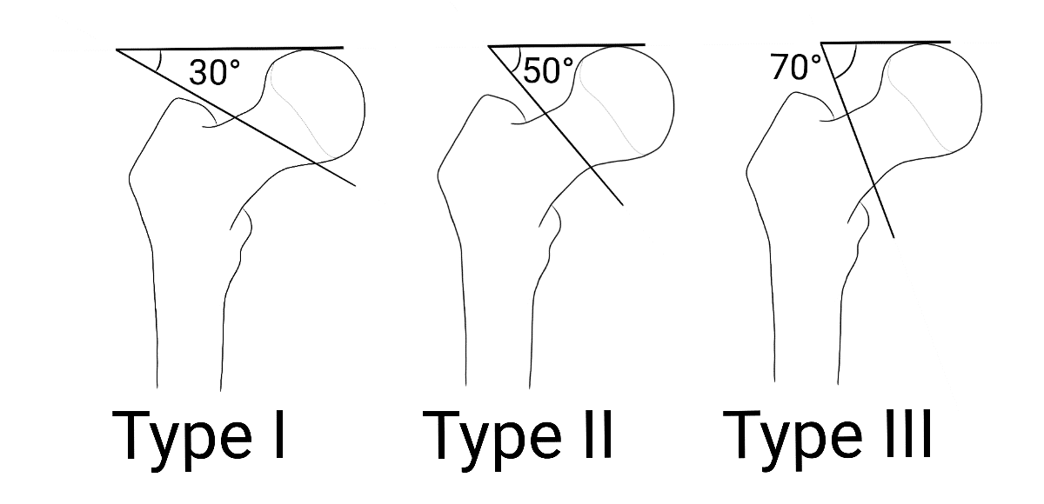

Displacement of Fracture
- Modified Garden Classification
  - Non-displaced – Grade I /Grade II
  - Displaced – Grade Type III / Type IV

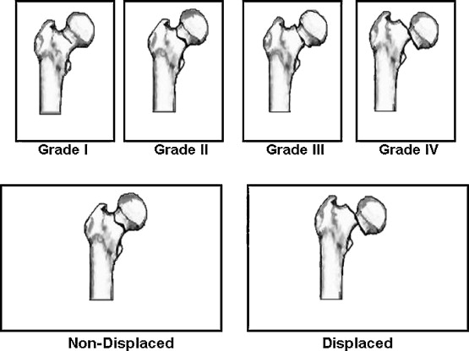
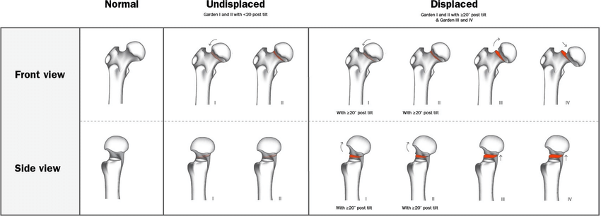
- Orthopedic Trauma Association Fracture Classification- Femoral Neck
- type B: femoral neck or subcapital femoral fracture (below the articular cartilage of the femoral head and above the intertrochanteric line)
  - B1: subcapital fracture
  - B1.1 valgus impacted
  - B1.2 nondisplaced
  - B1.3 displaced
  - B2: transcervical fracture (Pauwels 1-3: <30°, 30-70°, >70°)
  - B2.1 simple​
  - B2.2 multifragmentary
  - B2.3 shear fracture
  - B3: ​basicervical fracture
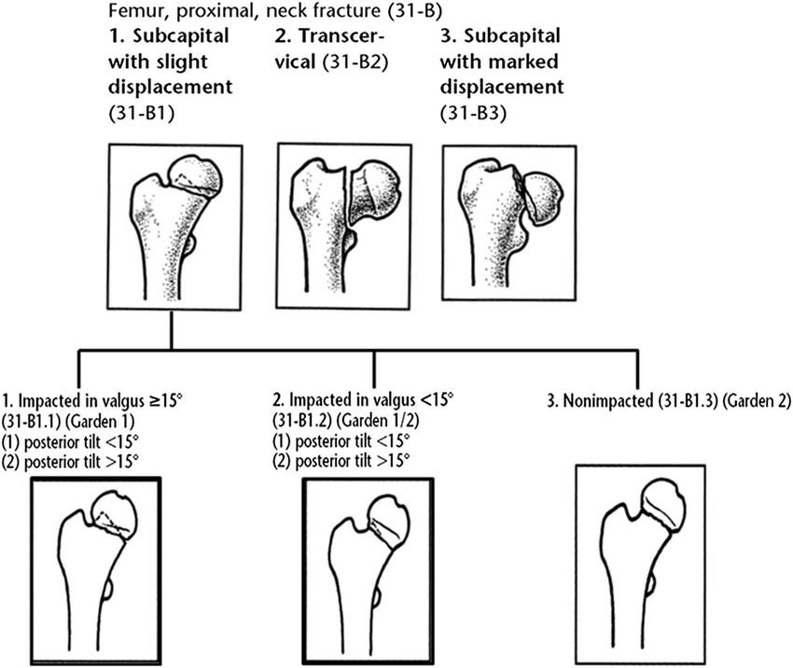
Proximal femoral physis
- Is the proximal femoral physis open or closed?
Triradiate cartilage
- Is the triradiate cartilage open or closed?
Oxford score
- Select the Oxford skeletal maturity score on the slider. Scoring guide:

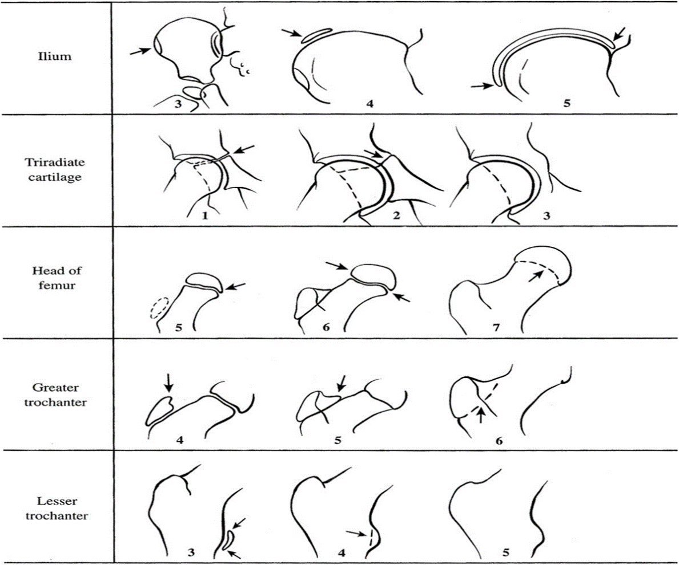
Comments on injury films
- Any comments on injury films go here.

Injury CT scan available
- Are injury CT scan films available? If answered yes:
  - Any additional comments regarding injury CT scan:
Injury MRI available
- Are injury MRI films available? If answered yes:
  - Any additional comments regarding injury MRI scan

Intra-op imaging
Is intraoperative imaging available?
- If intraoperative imaging in the form of fluoroscopy shots, O-arm, etc. is available. Please note that mm measurements can only be measured on calibrated images
  - Quality of reduction
    - Excellent: <2mm of displacement and <5 degrees of angulation in any plane on any view
    - Good: 2-5 mm of displacement and/or 5-10 degrees of angulation in any plane on any view
    - Fair: >5-10 mm of displacement and/or >10-20 degrees of angulation in any plane on any view
    - Poor: >10 mm of displacement and/or >20 degrees of angulation or any varus
  - Other comments
Post-op imaging
Is first post-op imaging available?
- This could be formal x-rays or CT-scans while admitted, or performed up to 4 weeks after surgery.
  - Date imaging was performed: MM-DD-YYYY
  - Quality of reduction
    - Excellent: <2mm of displacement and <5 degrees of angulation in any plane on any view
    - Good: 2-5 mm of displacement and/or 5-10 degrees of angulation in any plane on any view
    - Fair: >5-10 mm of displacement and/or >10-20 degrees of angulation in any plane on any view
    - Poor: >10 mm of displacement and/or >20 degrees of angulation or any varus
  - Femoral Neck Length: measurement of tip of greater trochanter to femoral head center on an AP Pelvis radiograph
    - Affected side:
    - Non-affected side:
  - Is hardware in stable position from intra-operative images? OPTIONAL if intraoperative imaging is available
  - Other comments on the first post-op images.

- Was a bone scan ever performed? A bone scan may be performed early after surgery or later if there is a concern for AVN. If available, enter the date it was done, and comments from the report or images.
  - Date imaging was performed: MM-DD-YYYY

Adverse event imaging
In adverse event imaging available? - XR/CT/MRI images that demonstrate progression or presence of AVN/malunion/non-union/hardware complication/etc. Yes/No

Date of Imaging

Time period of adverse outcome since surgery date
(≤ 3 mo, ≤6 mo, ≤12 mo, ≤18 mo, ≤24 mo)
Adverse IMAGING outcomes:
AVN
Malunion: defined as >5mm shortening of the femoral neck length compared to the contralateral side AND/OR quality of post-operative reduction as defined as “fair or poor”: >5 mm of fracture displacement or >10 degrees of fracture angulation on any plane on any XR view
Non-union: defined as non-healing of the fracture at 6 months post-surgery or change in hardware position or shortening of femoral neck length >5mm from initial post-operative imaging.
Hardware complications (backing out, breakage, penetrating joint, etc)
Other: with comments box

In case of AVN, select the FICAT stage

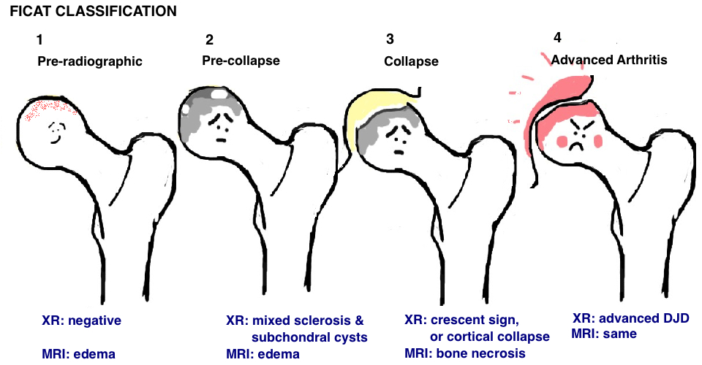

Final Imaging
Most recent imaging available: This could be formal x-rays or CT-scans performed at least 4 weeks after surgery
  - Date imaging was performed: MM-DD-YYYY
  - Quality of reduction
    - Excellent: <2mm of displacement and <5 degrees of angulation in any plane on any view
    - Good: 2-5 mm of displacement and/or 5-10 degrees of angulation in any plane on any view
    - Fair: >5-10 mm of displacement and/or >10-20 degrees of angulation in any plane on any view
    - Poor: >10 mm of displacement and/or >20 degrees of angulation or any varus
  - Femoral Neck Length: measurement of tip of greater trochanter to femoral head center on an AP Pelvis radiograph
    - Affected side:
    - Non-affected side:
- Is hardware in stable position compared to initial post-operative images?
  - Select adverse outcome(s) if encountered (or NONE)
  - In case of AVN, select the FICAT stage
  - For all adverse outcomes, please include a summary of findings in the textbox.

Appendix A

Bisphosphonates
Alendronate (Fosamax), Risedronate (Actonel), Ibandronate (Boniva), Zoledronic acid (Reclast), Etidronate (Didronel), and Pamidronate (Aredia)
Systemic Steroids
prednisone, methylprednisolone, prednisolone, and dexamethasone
Prostaglandins
Xalatan (latanoprost), Latisse (bimatoprost), and Cytotec (misoprostol)
Methylxanthines
theophylline, caffeine, and theobromine
Anti-Seizure medications
Acetazolamide
Brivaracetam available as Briviact
Cannabidiol available as Epidyolex
Carbamazepine also available as Tegretol, Tegretol Prolonged Release
Cenobamate available as Ontozry
Clobazam also available as Frisium, Perizam, Tapclob, Zacco
Clonazepam
Eslicarbazepine acetate available as Zebinix
Ethosuximide
Everolimus also available as Votubia
Fenfluramine available as Fintepla
Gabapentin also available as Neurontin
Lacosamide available as Vimpat
Lamotrigine also available as Lamictal
Levetiracetam also available as Desitrend, Keppra, Neuraxpharm.
Oxcarbazepine also available asTrileptal
Perampanel available as Fycompa
Phenobarbital
Phenytoin also available as Epanutin, Phenytoin Sodium Flynn
Piracetam available as Nootropil
Pregabalin also available as Alzain, Axalid, Lecaent, Lyrica
Primidone
Rufinamide available as Inovelon
Sodium valproate (important information for people with epilepsy under the age of 55 here) also available as Epilim, Epilim Chrono, Epilim Chronosphere, Episenta, Epival, Dyzantil
Stiripentol also available as Diacomit
Tiagabine available as Gabitril
Topiramate also available as Topamax
Valproic acid available as Convulex, Epilim Chrono, Epilim Chronosphere, Dyzantil
Vigabatrin available as Sabril, Kigabeq
Zonisamide also available as Zonegran, Desizon
Therapeutic heparin
Neuromuscular blockage
Rocuronium
Vecuronium
Pancuronium
Atracurium
Cisatracurium
Mivacurium
Doxacurium
Decamethonium
Loop diuretics
furosemide (Lasix), bumetanide (Bumex), torsemide (Demadex), and ethacrynic acid (Edecrin)

