Skeletal Age App Training Cases
Name PI or Delegate:
Name of CORTICES Site:

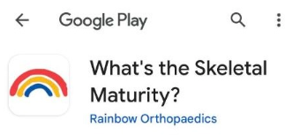
Instructions: Download from the Skeletal Maturity from the App Store or Google Play Store:
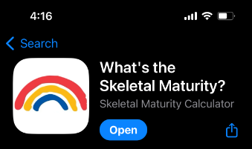

Use the Skeletal Maturity app in your phone to input values, but draw lines in this Word document using the “Insert” Tab and choosing the submenu “Shapes”.
To add straight lines choose the line icon 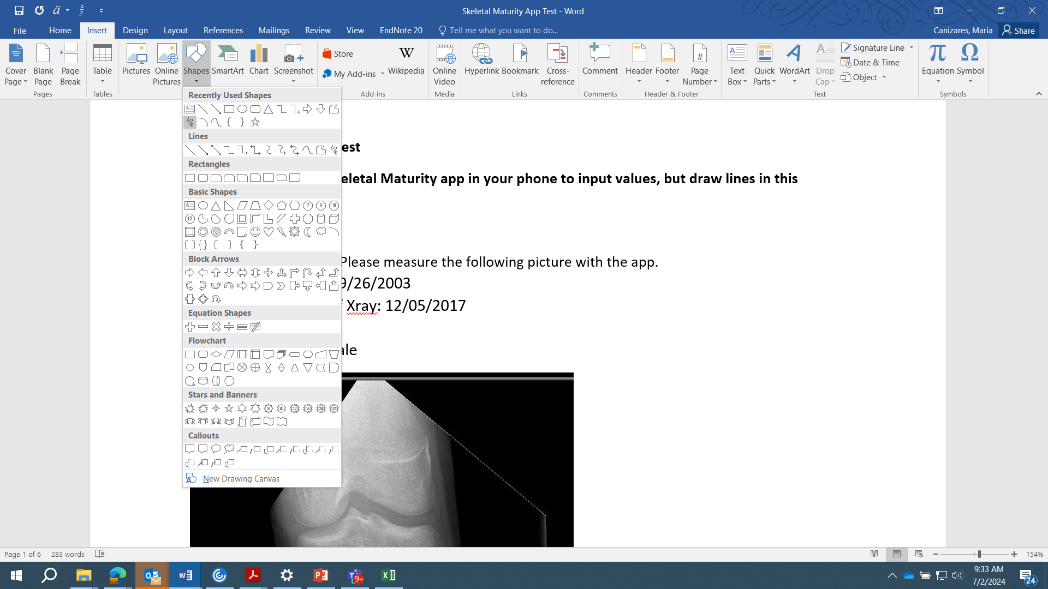, or to draw free hand shapes chose the scribble icon
To measure line length for the Tib-A and Fib-A ratios, draw the lines as instructed and then double click on the line you want to measure. You will see the “Drawing Tools” tab immediately highlighted and to the far right you will have the “Size” of the lines. Width is the measure at the bottom.
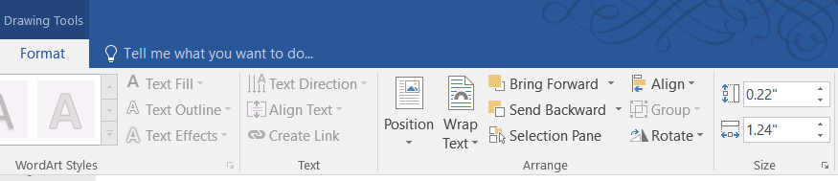
Please follow the instructions in the PPT document and enter the 1) Skeletal age you obtain for each case and your Tib-Q score as this will serve as our measure for inclusion criteria.

Training Cases
Follow instructions in the Skeletal Maturity App. Draw and measure lines here and plug numbers back into the app. You can delete or leave the lines after each measurement. Fill the table above with your findings. Send to Meghana and Fernanda with your name.
Results:
Case ID | Tib-Q score | Skeletal Age
01
02
03
04
05
06
07
08
09
10

- Patient 1:
  - DOB: 09/26/2003
  - Time of Xray: 12/05/2017
  - Age: 14
  - Sex: Male
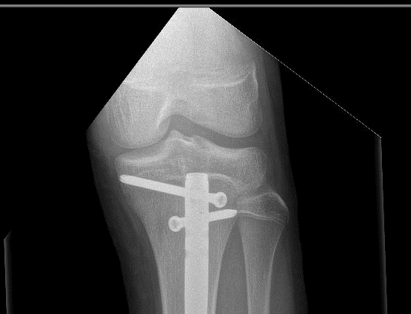

- Patient 2:
  - DOB: 07/31/2005
  - Time of Xray: 11/04/2019
  - Age: 14
  - Sex: Male
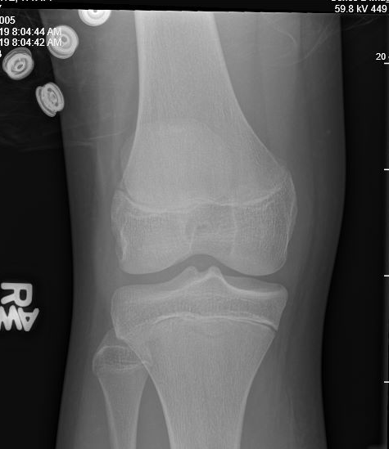

- Patient 3:
  - DOB: 08/22/2005
  - Time of Xray: 11/07/2020
  - Age: 15
  - Sex: Female
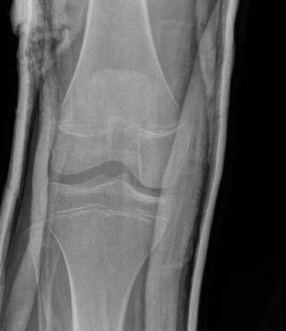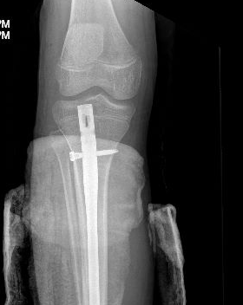

- Patient 4:
  - DOB: 02/03/2006
  - Time of Xray: 07/09/2022
  - Age: 16
  - Sex: Male
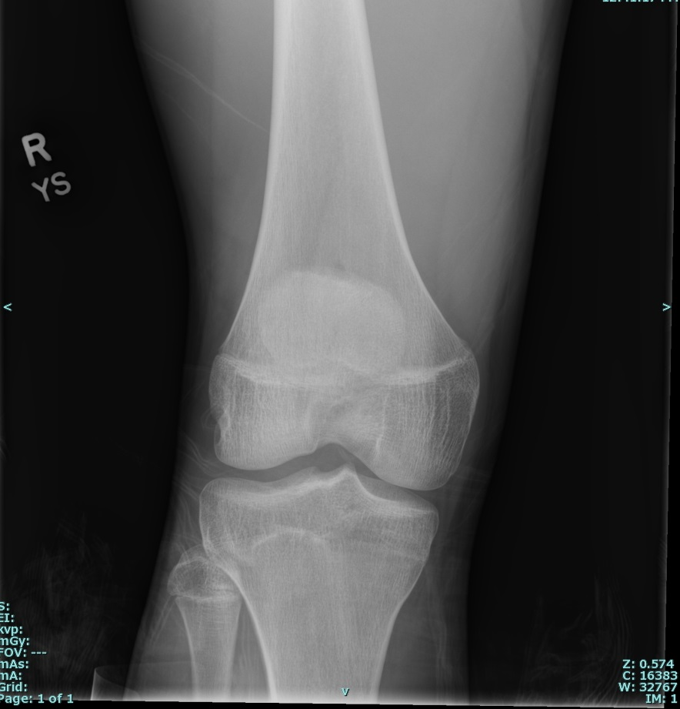

- Patient 5:
  - DOB: 06/19/2002
  - Time of Xray: 05/06/2017
  - Age: 14
  - Sex: Male
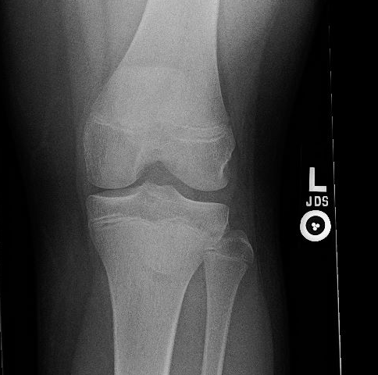

- Patient 6:
  - DOB: 05/18/2006
  - Time of Xray: 12/29/2019
  - Age: 13
  - Sex: Female
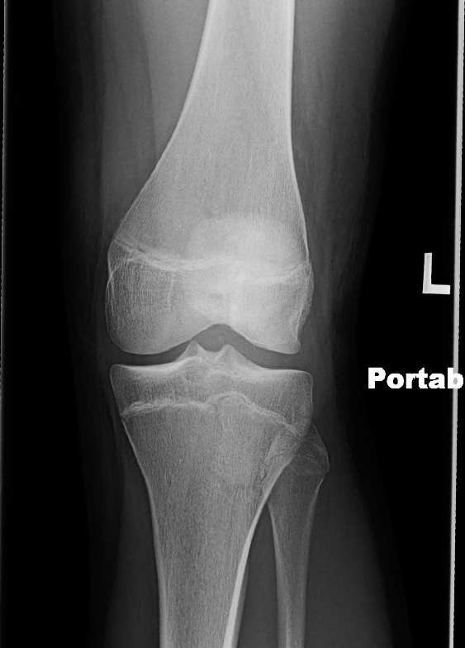

- Patient 7:
  - DOB: 07/28/1999
  - Time of Xray: 11/29/2014
  - Age: 15
  - Sex: Male

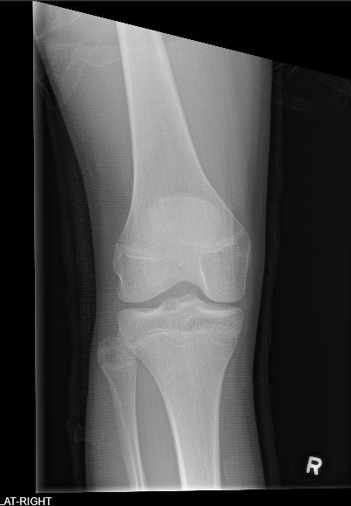

- Patient 8:
  - DOB: 01/20/2000
  - Time of Xray: 05/14/2015
  - Age: 15
  - Sex: Male
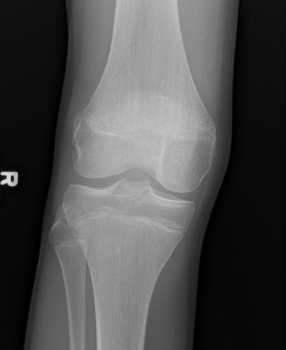

- Patient 9:
  - DOB: 07/07/2011
  - Time of Xray: 7/19/2022
  - Age: 11
  - Sex: Female
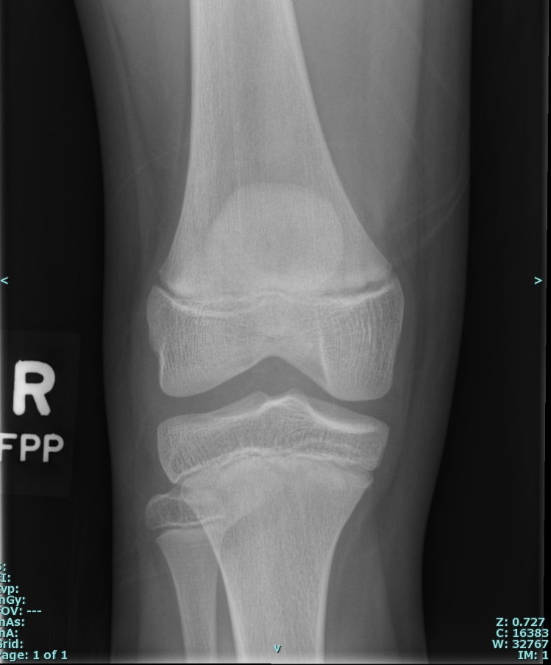

- Patient 10:
  - DOB: 08/20/2003
  - Time of Xray: 05/25/2019
  - Age: 15
  - Sex: Female
