

Retrospective Study Protocol

TITLE: Antegrade rigid intramedullary nailing of tibial diaphyseal fractures in adolescents with open proximal tibial physis

Study Summary: We hope to quantify iatrogenic deformity (if it exists) with the use of an antegrade rigid intramedullary tibia nail for treatment of tibial diaphyseal shaft fractures in adolescents with open proximal tibial physis. Our initial study will focus on retrospective collection of data which will hopefully provide support for a prospective study of this patient population.

- Specific Aims/Objectives
Primary Aim: Quantify proximal tibial iatrogenic deformity at skeletal maturity or after at least three months of follow-up in adolescents who were treated with antegrade rigid intramedullary nailing through an open proximal tibial physis for a diaphyseal tibial shaft fracture.
Primary Hypothesis: Antegrade rigid intramedullary nail fixation through an open proximal tibia physis in adolescents nearing skeletal maturity does not cause clinically significant proximal tibial deformity to within ±5° of change in relevant radiographic angulation and to within ±1cm of change in leg length discrepancy.
Primary Outcome: Change in deformity parameters from immediate postoperative to the most recent tibial radiograph either at/after skeletal maturity or at least three-months postoperatively including mechanical medial proximal tibia angle (mMPTA), mechanical posterior proximal tibial angle (mPPTA), and leg length discrepancy (LLD).

Secondary Aims, Hypotheses, Outcomes:
Aim 1: Estimate proportions of union, complication, and need for revision surgery in adolescents treated with rigid antegrade intramedullary nails
Hypothesis: Rate of bony union will be high and rate of complications and revision surgery will be low.
Outcome: Proportions of post-operative complications, radiographic union, and revision surgery.

- Background and significance
Antegrade rigid intramedullary nailing is a preferred technique for the treatment of tibial shaft fractures. Historically, there has been hesitance to perform antegrade rigid intramedullary nailing in adolescents with open proximal tibial physis due to concern of causing iatrogenic deformity in the proximal tibia. Although the effects of violating the proximal tibia physis with a rigid intramedullary nail is unknown, there has been increasing use of antegrade intramedullary nails in adolescents nearing skeletal maturity. We hope to quantify iatrogenic deformity (if it exists) with the use of an antegrade rigid intramedullary tibia nail for treatment of tibial diaphyseal shaft fractures in adolescents with open proximal tibial physis.

- Preliminary Studies
Rigid Intramedullary Nail Fixation in Adolescent Tibial Shaft Fractures: Effects on the Proximal Tibial Physis A retrospective review of 57 patients treated with IMN for tibial fractures was performed, with an average age of 15.4 years +/-1.48. There were 41 (71.9%) males and 16 (28%) females and 25 (43.9%) patients were skeletally mature and 32 (56.1%) were skeletally immature. The average follow up was 10.1 +/-9.5 months and the average time to union was 12.5±7.6 weeks (3-38 weeks). When assessing the entire cohort, there was a statistically significant greater preoperative MPTA preoperatively (87.7⁰) compared with postoperative (87.2⁰)(p = 0.010) as well as greater ADTA preoperatively (82.7⁰) compared with postoperative (81.9⁰)(p = 0.014) (Table 3a). However, on further sub-analysis including only the open and closing physes, there was no statistically significant difference between preoperative and postoperative MPTA, LDTA and ADTA. There was one patient who developed a leg length inequality and 2 patients who required an additional procedure after nonunion. (Submitted to JPO)

- Design and Methods
- Study Design
Retrospective
☐ Cohort ☐ Case-cohort ☐ Case-control ☐ Case series
Multicenter? ☒ Yes ☐ No

(2) Patient Selection and Inclusion/Exclusion Criteria
Inclusion criteria:
- All Tibial shaft fractures regardless of mechanism, clinical presentation or diagnosis including cases below:
  - bilateral fractures
  - prior treatment (i.e immobilized first)
  - concomitant fractures of the lower extremity or polytrauma
  - pathologic fractures
  - bone dysplasias or neuromuscular conditions
- Treated with rigid antegrade solid (non-Fassier-Duval) tibial IMN at a CORTICES institution between January 2010 and June 2023
- Age <18
- Open physes at treatment
Exclusion criteria:

(3) Description of Study Treatments or Exposures/Predictors
Adolescent patients with open physis who have been treated with antegrade rigid intramedullary tibial nailing

(4) Definition of Primary and Secondary Outcomes/Endpoints
What is Primary Outcome? Primary outcomes will include the change in mechanical medial proximal tibia angle (mMPTA), mechanical posterior proximal tibial angle (mPPTA), and leg length discrepancy (LLD) from immediately postoperatively to at/after skeletal maturity or at least three months postoperatively.

Radiographic measures including mMPTA and mPPTA will be measured on both AP and lateral radiographs and LLD will be measured either clinically or on radiograph if a standing image of both legs was obtained.

Secondary Outcome(s) and when it/they will be assessed?
Secondary outcomes will include postoperative complications including infection, VTE, compartment syndrome, nerve injury, physeal arrest, delayed/nonunion, unplanned return to OR, and ipsilateral extremity injury.

(5) Data Collection Methods, Assessments, Interventions and Schedule (what assessments performed, how often)
Research coordinators at each site will be responsible for the collection of all necessary data for this study. All data will be collected directly from sites’ own medical records and imaging databases, and trained research coordinators will enter it into a REDCap database that will be managed by the lead site (Boston Children’s Hospital). Data entered into the REDCap by participating sites will be de-identified, with the exception of dates relating to visits and procedures.

Medical records will be reviewed to obtain patient demographic, injury, treatment and follow-up characteristics including age, sex, BMI, menarche status, method of injury, fracture type, treatment method, follow-up physeal status, and radiographic measurements within three months of injury and at most recent radiograph following closure of tibial physis or at least three-months postoperative. See Appendix for comprehensive variable list.

(6) Study Timeline (as applicable) 1-1.5 years until submission for publication.
Protocol development: 1 month ~June 2023
Database creation: 1 month ~July 2023
Beta testing period: 1 months ~August 2023
Data entry 3-6 months Sept 2023-Feb 2024
Data Cleaning 0.5 month ~March 2024
Data Analysis 1.5 months April 2024
Writing: 2-4 months May-August 2024

- Data Management Methods
Where will data be entered and stored? Check all that apply.
☒ REDCap ☐ Excel ☐ Other, specify:
If multiple checked, please specify why:
Will anyone outside BCH need access to REDCap? ☒ Yes ☐ No ☐ N/A

- Quality Control Method
To minimize the risk of loss of patient data and maintain data according to institutional guidelines, we will use REDCap™ as the primary receptacle of our data management. REDCap™ is a secure software toolset and workflow methodology for electronic collection and management of research data. Real-time validation rules (with automated data type and range checks) at the time of entry will be incorporated by the BCH team at the time of project development.

Access to the REDCap ™ database will be set during the creation of the project assigning access to only members specified in the CORTICES Registry IRB protocol (BCH: IRB-P00036058) and participating institutions after local IRB and DUA requirements are met and verified by the BCH team. In addition, data collected will be recorded in such a manner (coded) that subjects will not be directly identified. The key code will be stored in a password-protected computer file only accessible to research personnel at each internal CORTICES site. All data entered into REDCap will have their own assigned unique study ID per patient and each institution will have a two-digit prefix unique to their site. Information about study subjects will be kept confidential and managed according to the requirements of the Health Insurance Portability and Accountability Act of 1996 (HIPAA).

To ensure standardized data entry across sites the team proposing the study will create and share a “data entry guide” document outlining variable definitions and measurement guidelines. All participating sites are responsible for their own data collection and entry into REDCap using proper methods.

A “beta testing” period with 3-5 institutions (including BCH) will be conducted in order to test REDCap project features such as branching logic, detect errors, and change any variable option before rolling out the study to all sites. Any data entered at the end of the testing period will have to be modified or cleaned according to the latest and final version of the codebook approved by the lead team at BCH and the team proposing the study.

After data entry has been finalized, the research team at BCH will generate individual data cleaning sheets that will be shared to each participating institution to address any missing data point or questionable entry. Each site will have 2 weeks to clean their data queries in order to be added to the final dataset for analysis.

If the analysis will be performed by BCH’s statistician, it will be required to have a Data Analysis Plan document mapping variables and requested tables and graphs prior to analysis. BCH will be in charge of generating the dataset for the BCH statistician or sending the data securely for analysis to other statistician from a CORTICES participating institution.

- Data Analysis Plan (Statistician should write this section)
Patient demographic, injury, treatment, and radiographic characteristics will be summarized for the cohort. The change in primary radiographic measurements will be estimated between immediate postoperaive and at the time of closure of the tibial physis or at least three months postoperatively along with 95% confidence intervals. For the primary analysis, equivalence testing using two one-sided tests will be used to assess if the change in deformity measures is negligible to within ±5 degrees for radiographic measures or to within ±1cm for LLD. For secondary aims, the proportions of complications, union, and revision surgery will be estimated along with 95% confidence intervals. If any deviations from our hypotheses are found (i.e. greater than 5 degrees of change or high proportions of complications, etc.) then multivariable regression analysis may be used to assess if there are any patient, injury or treatment characteristics associated with unexpected outcomes. If the sample is large enough, we will consider a sub analysis of just those patients whose physes are closed at the latest radiograph.

- Statistical Power and Sample Size Considerations (Statistician should write this section)
Power analysis determined that a sample as small as 30 subjects would provide more than 90% power for an equivalence test for each primary outcome using two one-sided t-tests at a 5% significance level when the actual mean is between 0 and 3 degrees, assuming the estimated standard deviation of the change in measurement(s) is conservatively 3 degrees, and the equivalence limits are ±5 degrees. However, if the true change in measure is 4 degrees or higher, then a sample around 80 subjects would be required to ensure equivalence to within 5 degrees. We expect to obtain data on around 300 patients which should provide ample power to assess equivalence in our multiple outcome measures with appropriate family-wise error adjustments as well as for stratified analysis for patients with closed physes versus those with short term follow-up.

- Study Organization
PI: Mark L Miller, MD
Co-Investigator(s): Julia Sanders, MD, Kathleen Rickert, MD, Zachary Meyer, MD
BCH Coordinator(s):
BCH Statistician: Patricia E. Miller
If multicenter, who is lead site?
☐ N/A ☐ BCH ☐ Other, include site name and PI:

- References
- Court-Brown CM et al. Intramedullary nailing of tibial diaphyseal fractures in adolescents with open physes. Injury 2003 Oct: 34(10): 781-5
- Deakin DE et al. Malunion following flexible IM nails for tibia fractures in adolescents. JCO 2010 Dec 4(6) 571-7
- Gordon JE et al. Complications after titanium elastic nailing of pediatric tibial fractures JPO 2007 27:4 442-6

APPENDIX
Comprehensive variable list
- Record ID
- Sex (M, F)
- Menarchy status (Pre-menarchal, post-menarchal, not recorded)
- DOB
- DOI (Calculate age at injury)
- BMI
- Mechanism of injury (MVA/MCA/ATV, Auto-ped, Sports, Fall from height, Other)
- DOS (Calculate age at surgery; Calculate time from injury)
- Surgical technique
- Reduction (Open, Closed)
- Nail technique (Suprapatellar, infrapatellar, Extraarticular lateral)
- Nail location (Above physis, at physis, below physis)
- If above, do interlocking screws cross physis? (Yes, No)
- Bone age
  - Was there a Left hand xray obtained within 3 months of injury? If so then calculate hand bone age using Greulich/Pyle
  - Was there an ipsilateral or contralateral knee radiograph obtained within 3 months of injury? If so then calculate Modified Fels/Liu bone age using Rainbow bone age app
- Fracture location (Distal 1/3, middle 1/3, proximal 1/3)
- Fracture characteristics (Transverse, spiral, oblique, comminuted)
- Fracture open (Yes, No)
- Fibula fracture (Yes, No)
- If yes, where (same level, distal, proximal)
- OTA classification:
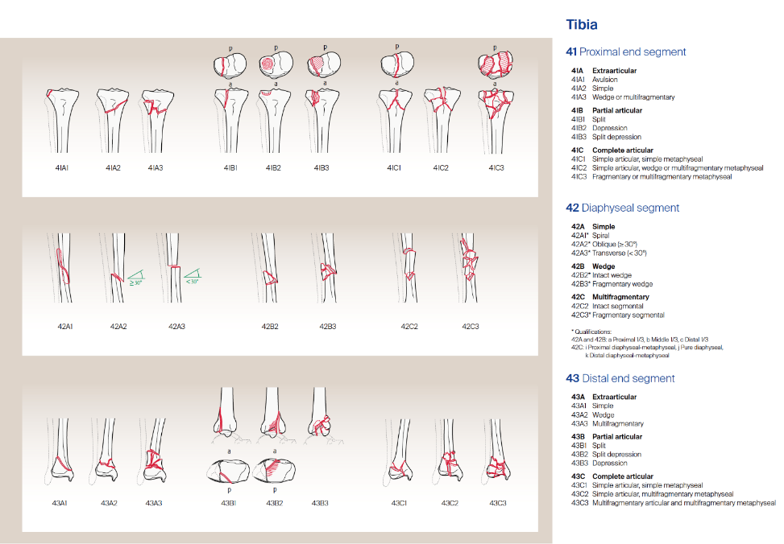

- Associated injuries (Ligamentous knee, Fracture, Head injury, Other)
- Time to radiographic healing (weeks)
- Post-op immobilization (Cast/splint (weeks), Boot (weeks), Other)
- Time to full weight bearing without assistance (weeks)
- Complications (Infection, VTE, Compartment syndrome, NV injury, Physeal arrest, Delayed/nonunion, Unplanned return to OR (ie other than HWR), Ipsilateral extremity injury, Other)
- Return to OR for HWR (Yes, No)
- If Yes, DOS
- Full return to activity/sport at same level? (Yes, No)
- Length of follow-up after injury
- Did patient reach skeletal maturity by the last postoperative visit? defined by closure of proximal tibia physis. How many months between injury and skeletal maturity?
- Xray measurements:
- First AP and lateral of tibia obtained post-operatively (within 3 months of injury); MPTA, LDTA, PPTA, ADTA
- AP and lateral of tibia obtained after skeletal maturity (closure of proximal tibial physis): MPTA, LDTA, PPTA, ADTA
- If patient was skeletally mature at last postop visit: latest AP and lateral of tibia: MPTA, LDTA, PPTA, ADTA
- Was a standing AP of both lower extremities obtained within three months of injury?
- Was a standing AP of both lower extremities obtained after skeletal maturity?
- If so, calculate: AP/lateral tibia, AP standing hips to ankles, Leg length discrepancy (mm), MAD (mechanical axis deviation) (mm)

