***Standard Operating Procedures for CORTICES Registry - Antegrade rigid intramedullary nailing of tibial diaphyseal fractures***

When entering your patient data, you will be asked to enter a new or existing Record ID. Please use your 2-digit Unique Site Number (shown below) for your site’s data.

|  |  |  |  |
| --- | --- | --- | --- |
| **Site #** | **Site** | **Site #** | **Site** |
| 20 | Boston Children’s | 30 | Le Bonheur Children’s/Campbell Clinic |
| 21 | Levine Children’s | 31 | Lurie Children’s |
| 22 | Children’s Atlanta | 32 | Nationwide Children’s |
| 23 | Children’s Colorado | 33 | Rady Children’s |
| 24 | Scottish Rite for Children | 34 | Seattle Children’s |
| 25 | Children’s LA USC | 35 | St. Louis Children’s |
| 26 | Children’s Philadelphia | 36 | Texas Children’s |
| 27 | Cincinnati Children’s | 37 | Vanderbilt Children’s |
| 28 | CS Mott Children’s | 38 | UCSF Benioff Children's Hospital |
| 29 | Gillette Children’s |  |  |

To generate your REDCap Record IDs, please use the following format (below), where ‘S’ is the 2-digit site code and ‘P’ is the 3-digit record ID. The IDs should be sequentially recorded.

|  |
| --- |
| **S S – P P P** |
|  | | | |
| 2-digit Unique **Site** Number | | |  |
| 3-digit Sequential **Patient** ID Number | | |  |

For example, BCH’s first patient would have a REDCap ID of “20-001”. BCH’s twentieth patient would have a REDCap ID of ’20-020’. It is crucial that sites use the correct site ID to avoid duplicate REDCap IDs.

**\*Note:** If you were a site involved with testing this REDCap and inputted training data (**BCH, WUSTL, Vanderbilt, Colorado, Nationwide, Campbell Clinic, Rady San Diego, Lurie Children’s**), please review all fields for your test patients as the REDCap was changed. You may keep the same Record ID for the test patient, but the data must be re-validated.

**CPT/ICD9/ICD10 Codes Search Query**

***CPT 27759:*** *Treatment of tibial shaft fracture (with or without fibular fracture) by intramedullary implant, with or without interlocking screws and/or cerclage*

CPT procedural codes are the same for flexible and rigid, so must look in OP report or x-ray to specify that we are finding patients who had surgery with a rigid intramedullary nail (IMN)

Although we know that CPT codes work for BCH and WashU we want to ensure that we collect all the patients that we have please also check the following diagnostic codes:

**ICD codes:**

**ICD-10: S82.20**

**ICD-9: 78.57 and 0QHG06Z**

|  |  |  |  |  |  |
| --- | --- | --- | --- | --- | --- |
| S52.222A | S82.222B | S82.242B | S82.291C | S82.402A | Y24.9XXA |
| S82.192B | S82.231A | S82.251A | S82.292A | S82.402B | S82.451A |
| S82.201A | S82.231B | S82.251B | S82.292B | S82.422B | S82.451B |
| S82.201B | S82.232A | S82.251C | S82.302A | S82.431A | S82.452A |
| S82.201C | S82.232B | S82.252A | S82.841A | S82.432A | S82.452B |
| S82.202A | S82.235A | S82.252B | S82.492B | S82.432B | S82.491A |
| S82.202B | S82.241A | S82.262A | S89.121A | S82.441A | -------------- |
| S82.222A | S82.242A | S82.291A | S82.401B | S82.492A | -------------- |

**Data Entry Phases: Will go through these phases of data entry for the study**

**Phase 1- XRAYS**: Coordinators will query the medical record using CPT codes, look through x-rays and determine if participant has a Rigid Tibia Nail.

**Phase 2- PIs Work**: Coordinators will send list/excel of participants with a Rigid Nail to PIs to determine Open/Closed Physis, grade of physis (0,1,2), and if eligible the PIs will enter Radiographic Measurements, Skeletal Maturity Age and additional PI specific data entry points

**Phase 3- Chart Data**: This information will be sent back to Coordinators for entry and additional chart review questions will be inputted through REDcap

# **Phase 1: XRAY Rigid Nail Identification**

**Coordinators will look through x-rays and determine if participant has a Rigid Tibia Nail**

For X-rays a singular nail will be shown for rigid nails and two nails in an almost X shape will be shown for flexible nails, **flexible nails make the patient ineligible.**

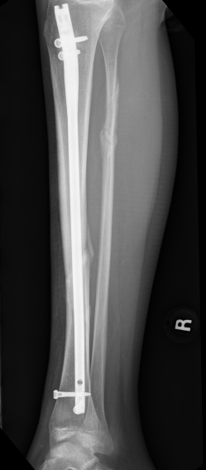

Figure 1: Rigid Nail

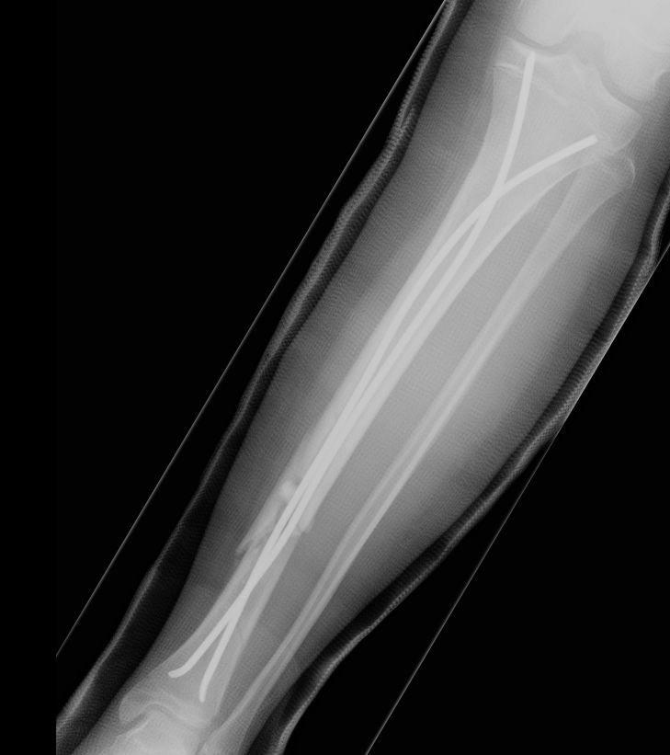

Figure 2: Flexible Nails (to be excluded)

**OP Report:**

To identify rigid nails, look for nails that are stated as being at least 7-8 mm in diameter or say rigid on the report. Also look for reports that specify only one nail being used.

Some examples of common manufactured rigid nails are Smith and Nephew IMN Trigen.

For flexible nails look for nail that are 2 to 4 mm in diameter, two nails will be used during surgery may also be called an elastic nail ex elastic titanium nail 3.5 mm. These will not be included in our data.

Common Manufacturer for flexible IMN nail is Synthes nail (be careful not to confuse with Synthes nail kit)

Note that growing rods, retrograde rush rods and rods that are hooked are not to be included. There will be some surgeries with screws only, those are also to be excluded.

# **Phase 2: PI Work**

**Coordinators will send list/excel of participants with a Rigid Nail to PIs to determine Open/Closed Physis, grade of physis (0,1,2), and if eligible the PIs will enter Radiographic Measurements, Skeletal Maturity Age and additional PI specific data entry points**

After all patients with rigid nails have been identified by the coordinator, these IDs must be sent to a PI. Determining whether a patient is skeletally immature by identifying an open physis may be difficult and subjective.

PI/designated individual must review all potentially eligible patients. An excel sheet template is provided to allow ease of eligibility screening for the PI.

This excel sheet will be used obtain the necessary radiographic measurements (See “Radiographic Measurements” section of the guide). If the PI is not doing the measurements, they need to determine who they are delegating the task to. (The designate must also attend all relevant trainings necessary for collecting skeletal age by use of the Skeletal Maturity App). Once the PI has determined which patients have open physes the coordinator will begin REDCap data entry.

**Study-Specific Definitions**

**Looking for patients with an open physis which are classified as skeletally immature**

**Open physis**

For this study, we will use lateral tibial physis fusion as the definition for an open physis that determines skeletal immaturity. This will be determined by use of the **Skeletal Age App** to grade lateral tibial physis fusion (TIB-Q). **Gradings of 0 and 1 will be included and a grading of 2 will be excluded.**

**Included**

Grade 0 (Absent fusion): Radiolucent gap between epiphysis and metaphysis visible thorough entire lateral proximal tibia

Grade 1 (Incomplete fusion): Gap between epiphysis and metaphysis only visible laterally

**Excluded**

Grade 2 (Complete fusion): Gap between epiphysis and metaphysis is completely gone

**Skeletal maturity: complete closure of the physis x-ray**

**X-ray examples of closed vs open physis**

Skeletal Immaturity- open physis (TibQ 0) Skeletal Immaturity- partially open physis (TibQ 1)

Skeletal Maturity- closed physis (TibQ 2)

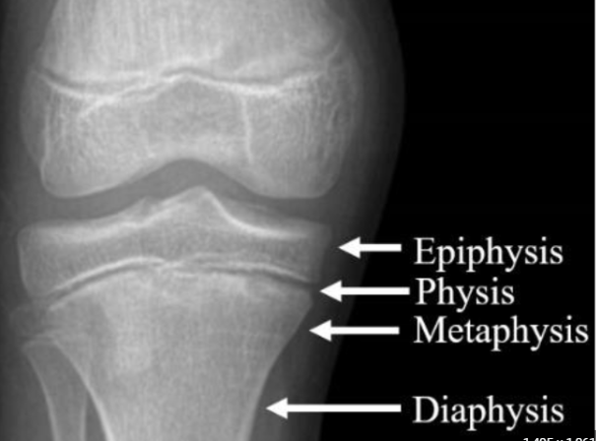

**Tibia shaft**

The tibial shaft (body) is the straight segment of the tibia between the expanded proximal and distal ends.

**Diaphysis**

The long tubular midportion of bone that ends in the metaphysis, the flared portion of bone that is separated from the epiphysis by the growth plate or physis.

# **Phase 3: Coordinator Chart Data Entry**

**This information will be sent back to Coordinators for entry and additional chart review questions will be inputted through REDcap**

**Form Completion Technique**

All data is to be entered directly into REDCap from the medical records.

When entering data, please follow the rules below:

1. Mark REDCap page status for each form as appropriate:
   1. **Incomplete (RED):** Data not fully entered
   2. **Complete (GREEN):** Data is fully entered
2. Use missing code field (no fields/questions should be left blank in order to be considered Complete)
   1. **-999** = missing/not recorded
      1. In instances where a field is not found in the medical record, or a measurement could not be done, please click the **M** icon next to the variable options and then choose **“missing/not recorded (-999)”.** Once the missing data code is chosen, the question becomes greyed out.

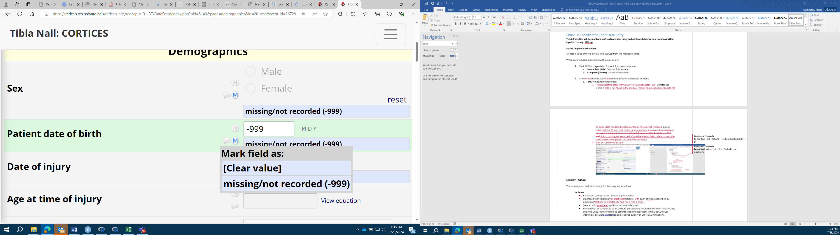

**Eligibility - REDCap**

The inclusion and exclusion criteria for the study are as follows:

***Inclusion:***

* Participant younger than 18 years at presentation
* Diagnosed with tibial shaft or diaphyseal fracture with open physes as identified by physician (*Defined as Skeletal Age App Tib-Q type 0 and 1)
* Treated with antegrade rigid tibial intramedullary nail
* Presented at or transferred to a CORTICES-participating institution between January 2010 and June 2024 (transfer refers to patients that did not present initially at CORTICES institution, but were transferred and received surgery at CORTICES institution).

***Exclusion:***

* Patient is missing first AP and lateral of tibia obtained post-operatively
* Patient has flexible rods, growing rods, retrograde rush rods and rods that are hooked
* Patients that only treatment was a nail removal at a CORTICES institution

If any of the inclusion criteria are not met or if any of the exclusion criteria are met, the patient is not eligible for further data collection. Answer “**No**” to the final question on this instrument and do not proceed. Otherwise, answer “**Yes**” and proceed to Data instrument.

**Data Entry**

*Demographics*

Patient sex

* Indicate whether patient is Male or Female
* Menarche

If Female, indicate if the patient is pre-menarchal, post-menarchal, or select missing/Not recorded field” if the answer is unattainable.

Patient date of birth

* Enter in the MM/DD/YYYY format

Date of Injury

* Enter in the MM/DD/YYYY format

Age at time of injury

* Calculated field- will display the age after date of birth and date of injury have been entered

Height

* Enter the patient’s height at presentation

Weight

* Enter the patient’s weight at presentation

BMI

* Calculated- will display after height and weight are entered

*Injury Characteristics*

Mechanism of injury

* Select the reported mechanism of injury.
* If “Other,” please specify in the open text field

**MVA/MCA/ATV**: MVA: Motor Vehicle Accident High impact, MCA: Motorcycles and moped Accident, All Terrain Vehicle Accident.

**Auto-ped**: Automatic vehicle vs. pedestrian, includes non-motorized bicycle vs. car, and children struck on skateboards and non-motorized scooters.

**Sports**

**Fall from height**: fall from greater than the height of the person

**Other**: Any mechanism not otherwise included

Date of surgery

* Enter in the MM/DD/YYYY format

Age at time of surgery

* Calculated field- will display after date of birth and date of surgery are entered

Time from injury

* Calculated field- will display after date of injury and date of surgery are entered

Surgical technique

* Indicate if the patient received an open or closed reduction (should be found in op note)

Nail technique

* Indicate the nail technique used (should be found in op note)
* Using the search tab in the op notes, use the words “suprapatellar, infrapatellar, and extraarticular lateral” to find the technique used

Nail diameter

* In mm (should be found in op note)

Nail length

* In cm (should be found in op note)

Nail manufacturer

* Should be found in op note

Nail location

* Select the location of the nail (should be found in op note)
* Do interlocking screws cross physis?

If “above physis” is selected, indicate whether the interlocking screws cross the physis

*In the example below, the top arrow shows the nail above the physis, and the bottom arrow points towards a screw that is below the physis and does not cross it*.

Was there a **LEFT** hand xray obtained within 3 months of injury?

* If yes, then calculate hand bone age using Greulich/Pyle
* Would be in radiologist or op note

Was there an ipsilateral or contralateral knee radiograph obtained within 3 months of injury?

* If yes, then calculate Modified Fels/Liu bone age using Skeletal age app
* <https://apps.apple.com/us/app/whats-the-skeletal-maturity/id1564285837>
* Use the link provided above and follow the instructions to calculate bone age.

Fracture location

* Select location of the fracture

Fracture characteristics

* Select the fracture type using the below criteria

|  |  |
| --- | --- |
| Transverse | Fracture line runs perpendicular to the bone axis |
| Spiral | Fracture line wraps around the bone; there may be 2 superimposed fracture lines and a fracture corner |
| Oblique | Fracture line is at an angle from the transverse plane; single fracture line |
| Comminuted | Fracture that is in 3 or more pieces |

(should be in op note)

Fracture open

* Indicate if the fracture was open (Not in reference to closed or open reduction) (OP Note)

Fibula fracture

* Indicate if there was a fibula fracture (OP Note)
* Location

If there was, enter location of fibula fracture

OTA Classification

* Use the figure provided in REDCap to determine OTA classification

Associated injuries

* Select any associated injuries that apply
* If “Other,” please specify in the open text field

Date of x-ray depicting radiographic healing

* Enter in the MM/DD/YYYY format
* (should be indicated in radiology or clinic note on the date images were obtained)

Time for radiographic healing

* Calculated field- will display after date of surgery and date of x-ray depicting radiographic healing are entered

Post-op immobilization

* Enter any applicable post-op immobilization
* If “Other,” please specify in the open text field
* For how long in cast/splint?
* For how long in boot?
* For how long in Other immobilization?
* For any post-op immobilizations selected, enter length of time in “weeks”

Date patient regained full weight bearing without assistance

* Enter in the MM/DD/YYYY format

Time to full weight bearing without assistance

* Calculated field- will display after date of surgery and “date patient regained full weigh bearing without assistance” are entered

Complications?

* Indicate if there were any complications

Complications

* If yes, select any complications that apply
* If “Other,” please specify in the open text field

Only list complications that are POST TREATMENT. Both deep and superficial infections are included. NV = nerve or vessel injury. Do not include Compartment syndrome or hardware removal as complications.

Return to OR for HWR

* Indicate whether patient returned to OR for HWR (hardware removal)

Date of Surgery

* Enter in the MM/DD/YYYY format

Full return to normal activities and sports??

* Indicate if patient returned to activities and sports

During last visit check note for mention of returning to normal activities

* If yes, then indicate if the activities/sports were at the same level as before the injury

Last date of follow-up after injury

* Enter in the MM/DD/YYYY format

*Radiographic Measurements*

*Coordinators will have PI’s fill out this section*

**We recommend having the PI fill out this section after determining if the patient is eligible with an open physis**

Was there a **LEFT** hand xray obtained within 3 months of injury?

* If yes, then calculate hand bone age using Greulich/Pyle
* Would be in radiologist or op note

Was there an ipsilateral or contralateral knee radiograph obtained within 3 months of injury?

* If yes, then calculate Modified Fels/Liu bone age using Skeletal age app
* <https://apps.apple.com/us/app/whats-the-skeletal-maturity/id1564285837>
* Use the link provided above and follow the instructions to calculate bone age.

Did patient reach skeletal maturity by the last postoperative visit?

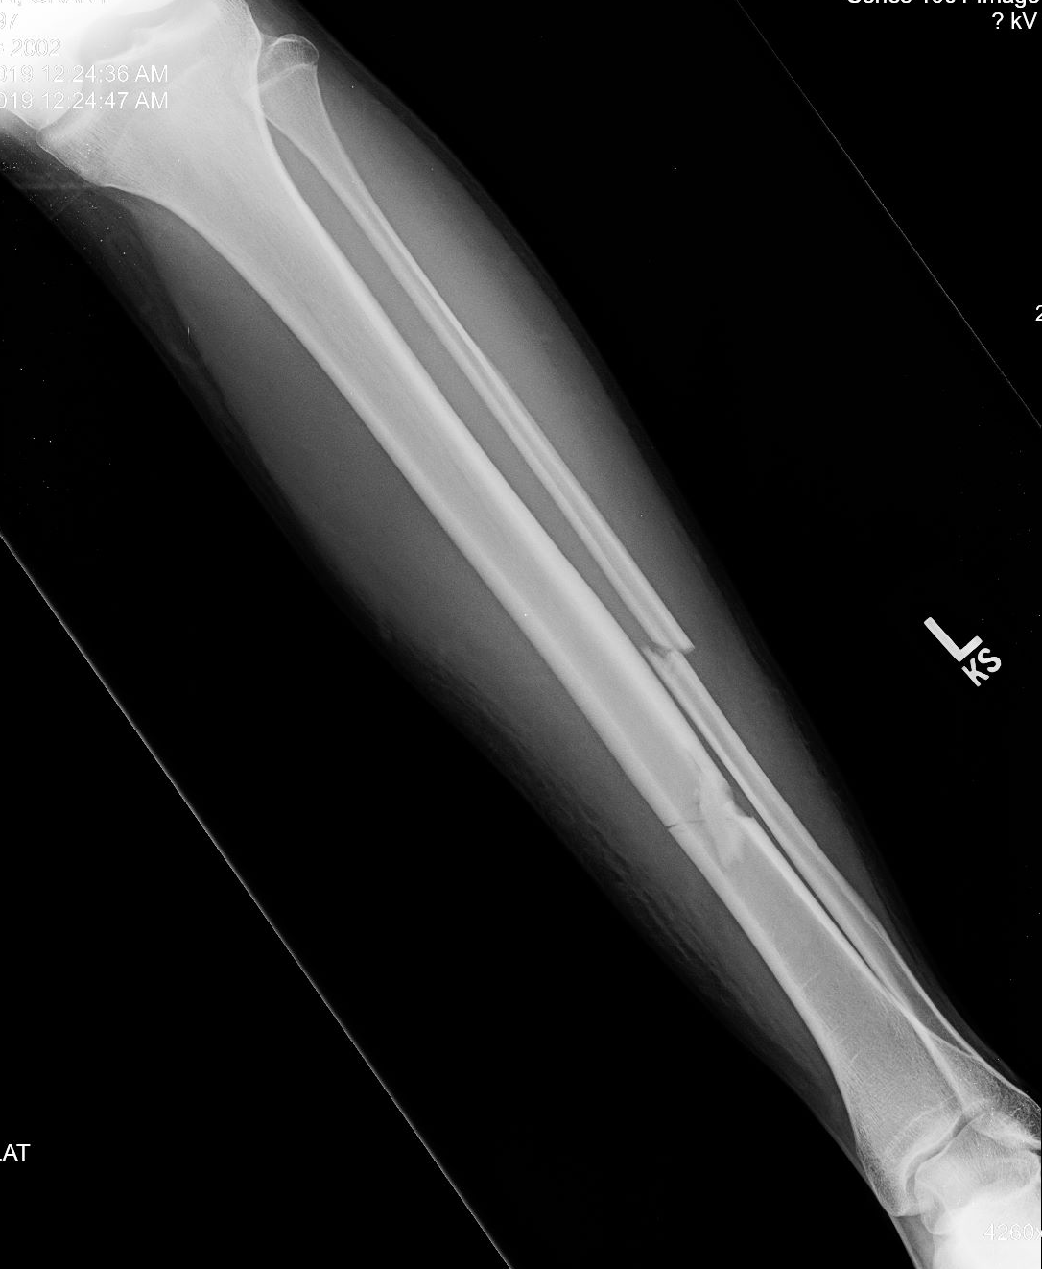

Skeletal Immaturity Skeletal Maturity

* X-ray on the left depicts an unclosed physis (skeletal immaturity) and the one on the right shows closure of the physis (skeletal maturity)
* Date skeletal maturity was observed
* Enter in the MM/DD/YYYY format
* How many months between injury and skeletal maturity?
* Calculated field- display after “date of injury” and “date skeletal maturity was observed”

First Ap and lateral of tibia obtained post-operatively [2 weeks to 4 months post-op]

* Enter
* Date of First Post-OP AP X-ray
* Date of First Post-OP LAT X-ray
* MPTA
* LDTA
* PPTA
* ADTA

AP and lateral of tibia obtained after skeletal maturity (closure of proximal tibial physis).

* Enter
* Date of AP X-ray
* Date of LAT X-ray
* MPTA
* LDTA
* PPTA
* ADTA

If patient was skeletally immature at last postop visit [2 weeks to 4 months post-op]: latest AP and lateral of tibia

* Enter
* Date of AP X-ray
* Date of LAT X-ray
* MPTA
* LDTA
* PPTA
* ADTA

Was a standing AP of both lower extremities obtained within 2 weeks – 4 months post-op?

* Enter

Date of Left X-ray

* Enter

Date of Right X-ray

* Enter

Was a standing AP of both lower extremities obtained after skeletal maturity was reached?

* Enter
* Date of Left X-ray
* Date of Right X-ray
* MPTA left
* MPTA right
* LDTA left
* ADTA right
* AP standing hips to ankles
* Leg length discrepancy
* MAD (mechanical axis deviation)

Supplemental Examples

Skeletal Immaturity (TibQ 0)  Skeletal Maturity (TibQ 2)

Skeletal Immaturity (TibQ 1) Skeletal Maturity (TibQ 2)